**Evaluation board for the maintenance-free power supply using energy harvesting and SLB series**

***EVSLB-AAA***

**User Guide**

**Description**

This is a small power supply board the size of a AAA battery that can be used as a power source to drive IoT systems, etc. This board can efficiently store energy generated from the environment sources, such as a photovoltaic energy, in Nichicon's small lithium titanate rechargeable battery: SLB series. By selecting and using an energy harvesting element and SLB that are suited to the load characteristics, a maintenance-free power supply can be constructed, allowing it to be used as a replacement for primary batteries. The board has a USB Type-C fast charging port, so it can quickly resume power supply operation even if the stored energy in the SLB runs out.

Note: This board has been prepared for the purpose of easy evaluation of the SLB series’ characteristics at

research and development, and we cannot guarantee its quality. This board is not intended to be used

in products or any part thereof.

**Features**

・All sizes of the Nichicon’s SLB series are available for mounting on the board

(Need to change or install some resistors to use with the SLB high temperature durable products.)

・e-peas AEM10300 PMIC for energy harvesting

Very low energy consumption, high energy conversion efficiency

・Supports an optimized configuration for efficient energy collection according to the characteristics of the

harvester

・The maximum charging voltage to the SLB series through the harvester can be set arbitrarily (custom mode)

・USB type-C fast charging port

　MAX77504(Analog Devices) charging IC, available for rapid charging for all sizes of SLB.

　（Need to change or install a current adjustment resistor to use the USB charging function）

The charging voltage and current to SLB from the USB port can be set to any value by changing the resistors.

・Built-in protection circuit against connection of non-standard USB Type-C products and connected device

malfunctions

・LED indicator that lights up when charging via USB

・Small PCB the size of a AAA battery

**Applications**

Power supply for various IoT devices using energy harvesting:

Devices powered by small capacity primary batteries (AA/AAA batteries, button batteries, etc.), installed in places where commercial power is not available, installed in places where power wiring is difficult, required maintenance-free operation, etc.

1. **Specifications**

・Energy harvester connection terminal (Input): PCB pad

Input voltage range : 0.1～4.5V (DC)

Also possible to input rectified output of AC harvester whose rectified voltage satisfies the above.

Input power range : 3μW～570mW

Cold start voltage/power : 275mV / 3μW

・SLB connection terminal (Input): PCB pad

Attachable SLB : All parts in the lineup

Be careful not to get the polarity wrong or short the leads.

・Load connection terminal (Output): PCB pad …Direct connection to SLB mounting pad

Output voltage range : 2.7V～1.8V (*1)

Maximum output current :　Depends on the SLB part selected

Be careful not to get the polarity wrong or short.

(*1) The maximum voltage (initial setting=2.7V) is determined by the PMIC and USB charger settings.

When using SLB high temperature durable products, set OVP value becomes this maximum voltage.

And external SLB over-discharge protection function is required.

・Configuration of maximum power point tracking (MPPT) control for energy harvester

Harvesting voltage : 7 selectable levels available:

60%, 65%, 70%, 75%, 80%, 85%, 90% of open circuit voltage (OCV)

(initial setting = 80%)

MPPT timing : Sampling duration of OCV =70.8ms, Sampling period=4.5s (Fixed)

・Overcharge protection for SLB (Energy harvesting input) : 2.70V

Configurable to any value in custom mode, refer to ***4.2 Board settings, step-2***.

Need to change to use with the SLB high temperature durable products.

・Over-discharge protection for SLB : Not installed (The function should be implemented on the load side)

・Fast charging port (Input) : USB type-C

Input voltage: 5V

Input current: Variable (Depends on the resistor used; *2)

(*2) Not available for charging via USB if the charge current setting resistor is not installed.

Charging voltage of SLB+: 2.65V (initial setting)

Configurable to any value by changing the resistors, refer to ***4.2 Board settings, step-3.***

Need to change to use with the SLB high temperature durable products.

Charging current of SLB: max. 500mA (initial setting)

Configurable to any value by changing the resistor, refer to ***4.2 Board settings, step-4.***

・Dimensions : 45mm×12mm×5.5mm

Please refer to individual datasheets for details:

　Small Lithium Titanate Rechargeable Battery - ”SLB” series:

<https://nichiconbattery.com/>

PMIC for energy harvesting - AEM10300（e-peas）：

<https://e-peas.com/product/aem10300-solar-battery-charger-up-to-7-cells/>

DC/DC converter - MAX77504（Analog Devices）：

<https://www.analog.com/en/products/max77504.html>

USB type-C port detection & protection IC - BD91N01NUX（Rohm）：

<https://fscdn.rohm.com/en/products/databook/datasheet/ic/interface/usb_pd/bd91n01nux-e.pdf>

MOSFET used for power path switch - DMP1009UFDF（Diodes）：

<https://www.diodes.com/datasheet/download/DMP1009UFDF.pdf>

1. **Appearance and user interfaces**

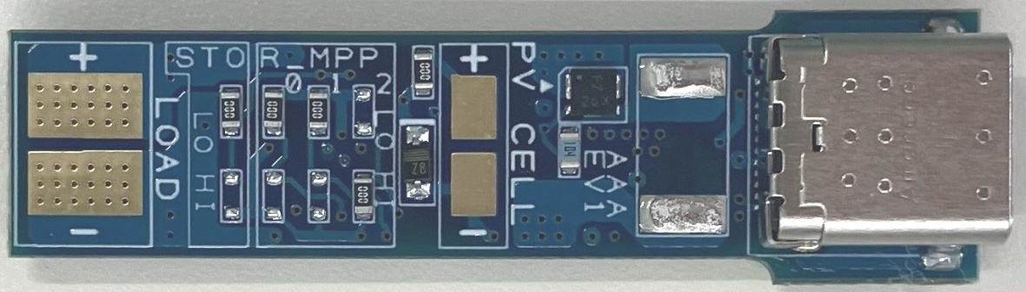

**5**

**4**

**2**

**3**

**6**

**1**

Fig 2-1 Front Side

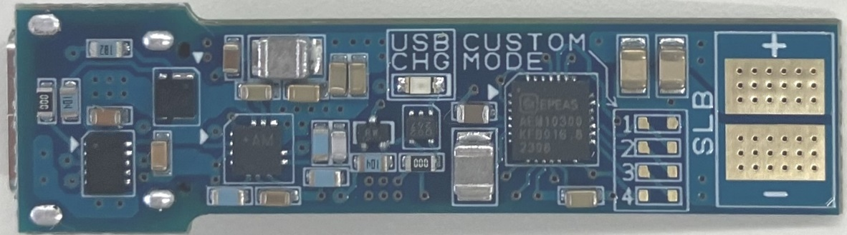

**7**

**10**

**8**

**9**

Fig 2-2 Back Side

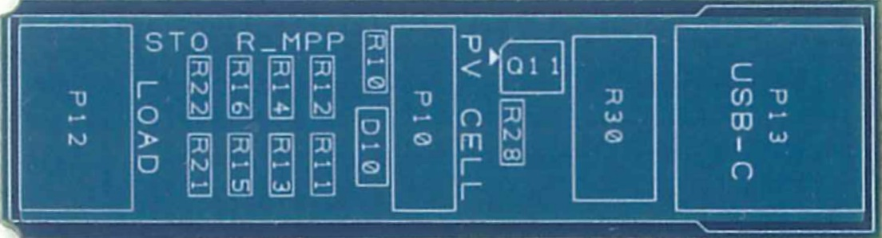

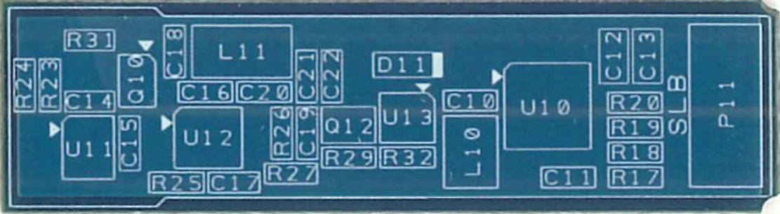

Fig 2-3 Accessory board for checking reference numbers

(Top: front side, bottom: back side)

Table2 Function of each part

|  |  |  |  |
| --- | --- | --- | --- |
| No. | Name | Ref-No. | Description |
| 1 | USB charging port | P13 | By connecting a USB-C cable here, the SLB can be charged via USB. To enable charging via USB, it is necessary to calculate the value of R30 that will result in the desired charging current for the SLB being used. Then mount the appropriate resistor in advance of usage. Please connect a power supply that complies with the USB Type-C standard. |
| 2 | Resistor to set the current of SLB charging  (for USB path） | R30 | This resistor sets the SLB charging current from the USB terminal. Determine the desired charging current within the rating of the SLB to be used, calculate the resistance value that can supply current, and then connect the resistor. The initial setting is 2 ohms, and the resistor should be replaced if the desired current is different. The mounting pad is 6432 size (2512 in inches). Please pay attention to the power rating of the using resistor.  For more information, see ***4.2 Board settings, step-4***. |
| 3 | PCB pad to connect the energy harvester | P10 | Input terminal for connecting energy harvesting elements such as PV cells. Check the polarity of the energy harvester output before soldering the wires. Pay attention to the output characteristics of the energy harvester and do not exceed the input rating of this board. For efficient energy harvesting, refer to ***4.3 Initial settings and general information on the specifications.***  Even if the energy harvester is an RF harvester or other AC harvester, it can be connected and used with this board as long as its output is rectified before being input to the board and does not exceed the input rating. |
| 4 | Resistor to set the MPP ratio | R11～R16 | Jumper resistors to set the maximum power point tracking (MPPT) ratio parameters. Set to ensure optimal energy harvesting efficiency based on the characteristics of the energy harvester being used.  For more information, see ***4.2 Board settings, step-1***. |
| 5 | Resistor to select the charging voltage for SLB  (for energy harvesting path) | R21, R22 | Jumper resistors to set the maximum SLB charging voltage (overcharge protection voltage) from the energy harvester.  You can select either the preset voltage of 2.70V or any user selected setting (custom mode). If you select the custom mode, you should also mount resistors described No. 9 in this table.  Need to change the setting to use with the SLB high temperature durable products.  For more information, see ***4.2 Board settings, step-2***. |
| 6 | PCB pad to connect the load circuit | P12 | Connect the load circuit to be supplied power from this board. Be careful to solder the power line wires to prevent reversed polarity.  The load circuit should have a function to prevent over-discharging of the SLB (for example, a current path cutoff or automatic shutdown by voltage monitoring). |

* Table 2 Continued -

|  |  |  |  |
| --- | --- | --- | --- |
| No. | Name | Ref-No. | Description |
| 7 | USB charging LED | D11 | Illuminates when the SLB is charging via the USB port.  For more information, see ***4.3 Initial settings and general information on specifications.*** |
| 8 | Resistor to set the charging voltage for SLB  (for USB path) | R26, R27 | These resistors configure the resistor divider to set the SLB charging voltage from the USB terminal. The initial values ​​are R26 = 39.2kΩ and R27 = 11.5kΩ, the preset charging voltage is 2.65V. They can be changed as necessary.  Need to change the setting to use with the SLB high temperature durable products.  For more information, see ***4.2 Board settings, step-3***. |
| 9 | Resistor to set the charging voltage for SLB  (custom mode) | R17～R20 | Resistors to set the maximum SLB charging voltage (overcharge protection voltage) from the energy harvester to any value in the custom mode. If you want to set the voltage to a value other than the preset 2.70V, select custom mode by R21 and R22 (No. 5 in this table) and mount resistors of appropriate values ​​in R17 to R20.  Need to change the setting to use with the SLB high temperature durable products.  For more information, see ***4.2 Board settings, step-3***. |
| 10 | PCB pad to mount the SLB | P11 | Install the SLB of the desired capacity and use it.  Be very careful of the polarity when soldering as there is no protection circuit implemented against incorrect polarity. |

1. 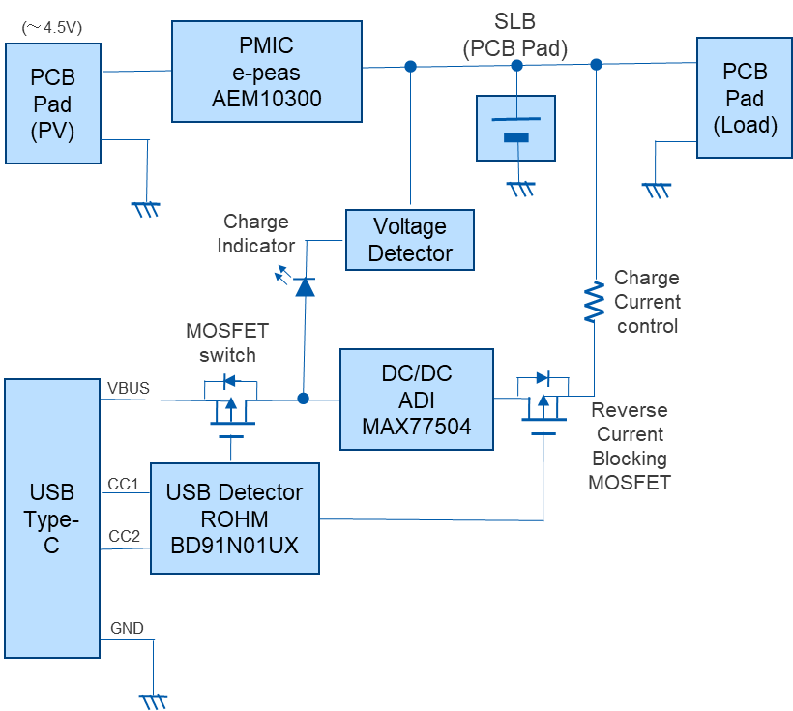**Circuit configuration**

* A function to prevent over-discharge of the SLB

is required on the load side.

Fig 3 Block diagram

1. **How to use the board**

**4.1 Precautions for use**

* Before installing the SLB, energy harvester, and external circuit, please complete the necessary mounting, removal, and replacement of components on the board. In particular, if you process these operations with the SLB installed, there is a risk of damage to circuit components or electric shock due to unintentional short circuits. Also, when setting up the USB fast charging, pay attention to the component rating of the current setting resistor.
* Before installing the SLB, please make sure that the charging voltage and current settings are within the rated range of the SLB you are using. When installing the SLB and external wiring, pay close attention to the polarity. This board does not have a protection circuit against reverse polarity installation of SLB, so installing the SLB with the wrong polarity will damage the circuit.
* Do not short-circuit the load connection wires or the +/- terminals of the SLB. This may not only deteriorate the performance of the SLB, but may also damage the board and surrounding circuits and/or cause smoke.
* Carefully check the output characteristics of the energy harvester to be connected and take protective measures as necessary to ensure that the maximum ratings of the PMIC mounted on this board are not exceeded.

In addition, do not directly connect a device with low output impedance, such as a stabilized power supply, to the energy harvester connection terminal. This may result in malfunction, abnormal heat generation, or damage to the PMIC.

* This board does not have an over-discharge protection for SLB, so basically it needs to implement a function to prevent over-discharge of SLB on the load side (such as monitoring the power supply voltage and cutting off the current or stopping the load operation if it falls below a specified voltage). If over-discharge can be avoided by the operating specifications of the load circuit, the over-discharge protection circuit is not necessary, but please consider carefully before deciding whether or not to include a protection circuit.
  1. **Boad settings**

Step1. Setting of MPPT function

Optimize the PMIC harvest voltage to match the characteristics of the energy harvester to be connected.

First, refer to the datasheet of energy harvester to be use, find the ratio of the open circuit voltage (OCV) and maximum power point (MPP) voltage of the energy harvester under actual conditions of use. Next, find the R_MPP setting that gives the closest ratio from Table 4-2-1a, and set the MPP ratio with resistors R11 to R16.

On this board, the MPPT timing and power mode are fixed (see the Table 4-2-1b/c).

For details on PMIC parameter settings, please refer to the AEM10300 datasheet.

<https://e-peas.com/product/aem10300-solar-battery-charger-up-to-7-cells/>

Table 4-2-1a MPP ratio setting “☑”is short by using jumper resistor, “DNP” mounts nothing.

|  |  |  |  |  |  |  |  |
| --- | --- | --- | --- | --- | --- | --- | --- |
| R_MPP [2] | | R_MPP [1] | | R_MPP [0] | | MPP  ratio | Remarks |
| R11  (High: 1) | R12  (Low: 0) | R13  (High: 1) | R14  (Low: 0) | R15  (High: 1) | R16  (Low: 0) |
| DNP | ☑ | DNP | ☑ | DNP | ☑ | 60% |  |
| DNP | ☑ | DNP | ☑ | ☑ | DNP | 65% |  |
| DNP | ☑ | ☑ | DNP | DNP | ☑ | 70% |  |
| DNP | ☑ | ☑ | DNP | ☑ | DNP | 75% |  |
| ☑ | DNP | DNP | ☑ | DNP | ☑ | 80% | Initial setting |
| ☑ | DNP | DNP | ☑ | ☑ | DNP | 85% |  |
| ☑ | DNP | ☑ | DNP | DNP | ☑ | 90% |  |
| ☑ | DNP | ☑ | DNP | ☑ | DNP | ZMPP | Not available |

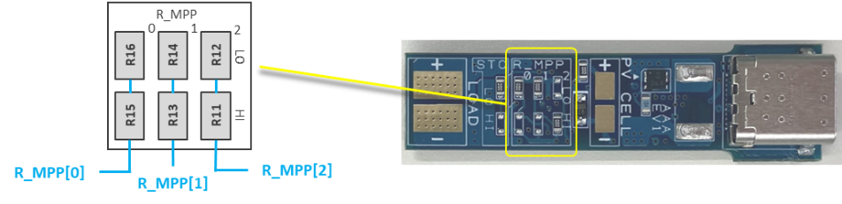

Fig 4-2-1 Location of MPP setting resistors on the board

Table 4-2-1b MPP timing setting

|  |  |  |  |  |
| --- | --- | --- | --- | --- |
| T_MPP [1] | T_MPP [0] | Sampling duration | Sampling period | Remarks |
| 0 | 0 | 5.19ms | 280ms | Not available |
| 0 | 1 | 70.8ms | 4.5s | Initial setting (Fixed) |
| 1 | 0 | 280ms | 17.87s | Not available |
| 1 | 1 | 1.12s | 71.7s | Not available |

Table 4-2-1c Power mode setting

|  |  |  |
| --- | --- | --- |
| EN_HP | Power mode | Remarks |
| 0 | Low power mode | Initial setting (Fixed) |
| 1 | High power mode | Not available |

Step2. Setting of the maximum SLB charging voltage (overcharge protection) from the energy harvester

Sets the overcharge protection voltage (OVP) threshold for the SLB series when charging from an energy harvester. There are two options available, select one by attaching or detaching R21 and R22.

(a) 2.70V

(b) Any voltage setting (by using the custom mode)

For details on PMIC parameter settings, please refer to the AEM10300 datasheet.

<https://e-peas.com/product/aem10300-solar-battery-charger-up-to-7-cells/>

Table 4-2-2a Setting of OVP threshold “☑”is short by using jumper resistor, “DNP” mounts nothing.

|  |  |  |  |  |  |  |  |
| --- | --- | --- | --- | --- | --- | --- | --- |
| STO_CFG [3]  Fixed | STO_CFG [2] | | STO_CGF [1]  Fixed | STO_CFG [0] | | OVP  threshold  (VOVCH) | Remarks |
| R21  (High: 1) | R22  (Low: 0) | R21  (High: 1) | R22  (Low: 0) |
| 0 | DNP | ☑ | 1 | DNP | ☑ | 2.70V | Initial setting |
| 0 | ☑ | DNP | 1 | ☑ | DNP | Any value | Custom Mode |
| Not selectable the other settings | | | | | | － | Not available |

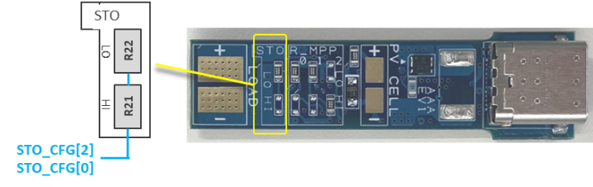

Fig 4-2-2a Location of OVP setting resistors (energy harvesting path) on the board

(a) If using the preset value of 2.70V, do not implement anything in R17 to R20.

(b) If using the custom mode, R17 to R20 should be implemented.

When using with SLB high temperature durable products you need to change the voltage setting by selecting the custom mode.

Calculate each resistance value using the formula below. VOVCH is the maximum charging voltage (overcharge protection voltage).

*VOVDIS and VCHRDY are not used to control this board, so you can freely determine their values, but the resistance values ​​of R17 to R20 should satisfy the conditions shown in the calculation formula.

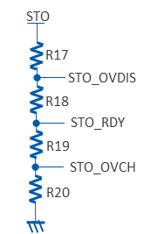

$$V_{OVCH} [V]=1+\frac{R17+R18+R19}{R20}$$

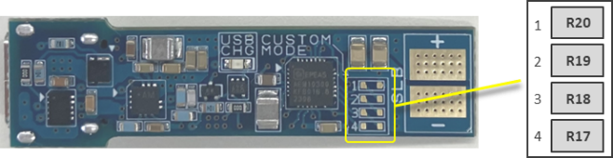

$$RT=R17+R18+R19+R20, 1MΩ+≤RT≤100MΩ$$

$$R20=RT∙\frac{1}{V_{OVCH}}$$

$$R19=RT∙\left(\frac{1}{V_{CHRDY}}-\frac{1}{V_{OVCH}}\right)$$

$$R18=RT∙\left(\frac{1}{V_{OVDIS}}-\frac{1}{V_{CHRDY}}\right)$$

$$R17=RT∙\left(1-\frac{1}{V_{OVDIS}}\right)$$

$$V_{OVDIS}+0.05V+≤V_{CHRDY}≤V_{OVCH}-0.05V$$

$$V_{OVCH}≤2.80V$$

Fig 4-2-2b

Location of custom mode setting resistors

*When setting the voltage using custom mode, it is useful to use the configuration tool provided in the PMIC datasheet link, that makes it easy to calculate resistance values.

Table 4-2-2b Setting example of resistors when using with SLB high temperature durable products

|  |  |  |  |  |  |
| --- | --- | --- | --- | --- | --- |
| Resistors for mode setting | | Resistors for the setting of threshold voltage | | | |
| R21 | R22 | R17 | R18 | R19 | R20 |
| ☑ | DNP | 4.7MΩ | 1.2MΩ | 2MΩ | 5.6MΩ |
| Custom Mode | | VOVCH = 2.41V (VCHRDY=1.99V, VOVDIS=1.53V) | | | |

“☑”is short by using jumper resistor, “DNP” mounts nothing.

Step3. Setting of the maximum SLB charging voltage (overcharge protection) from the USB path

The charging voltage of the SLB series when charging via USB Type-C connection is preset to 2.65V.

If it needs to be changed, calculate the values ​​of R26 and R27 according to the formula below and replace the corresponding resistors.

$$V_{CHG(USB)}=0.6∙\left(1+\frac{R26}{R27}\right), R27≥10kΩ$$

When using with SLB high temperature durable products you need to change the voltage setting by changing the resistors.

Below is an example of the resistance value using with SLB high temperature durable products.

$$R26=47kΩ, R27=16kΩ ⇒ V_{CHG(USB)}=2.36V$$

For details of parameter settings, please refer to the MAX77504 datasheet.

<https://www.analog.com/en/products/max77504.html>

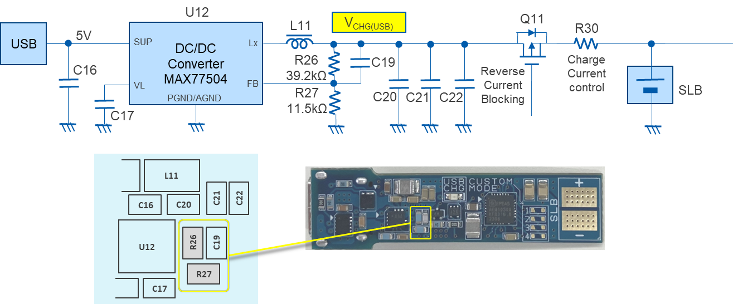

Fig 4-2-3 Overview of the USB charging circuit and the location of the corresponding components

Step4. Selecting the SLB and setting the SLB maximum charging current from the USB path

Select the suitable SLB based on the characteristics of the application in which this board will be used.

Once the SLB to be used has been decided, calculate the maximum current from the USB path within the range of the SLB rating using the formula below, and mount a resistor with an appropriate rating on R30. The mounting pad is 6432 (2512 in inches) in size.

$$I_{CHG(USB)MAX}=\frac{V_{CHG(USB)}-V_{B min}}{R30}$$

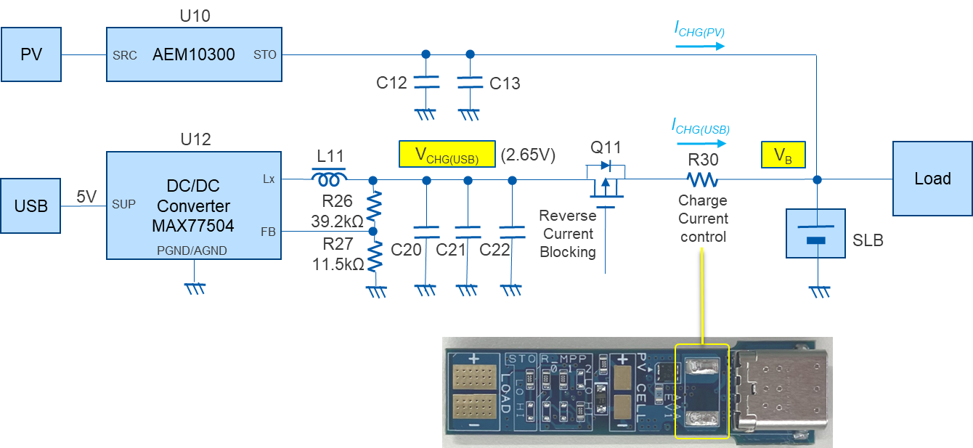

Fig 4-2-4 Overview of the SLB charging circuit on the board

◇The maximum charging current value calculated using the formula should be within the rating of the SLB

being used. VB min may drop to the externally set over-discharge protection voltage, but because there is little energy that can be stored around the SLB's rated lower limit voltage, even when charging from rated lower limit voltage, the SLB voltage will rise to a certain level in a relatively short time (approx.2.1V～2.2V on the SLB normal products, approx.1.9V～2.0V on the SLB high temperature durable products). Therefore, for example, even if the case which over-discharge protection is externally set to around rated lower limit voltage (ex. 1.8V on the SLB normal products, 1.5V on the SLB high temperature durable products) and the SLB is charged from USB immediately after over-discharge protection is activated, it is often acceptable to charge using a resistance value that is calculated as the VB min in the formula is defined as the above certain voltage (2.1V～2.2V on the SLB normal products, 1.9V～2.0V on the SLB high temperature durable products). But please carefully consider under actual conditions whether that setting is problem-free.

◇The current value for charging the SLB via the USB path is determined passively in proportion to the

difference between the maximum charging voltage set in step 3 and the real-time voltage of the SLB. Thus, as charging progresses and the SLB voltage rises, the SLB charging current decreases in inverse proportion to it. Therefore, it takes longer to fully charge compared to CC/CV charging.

◇When setting the maximum charging current to a large value (and/or) using a large capacity SLB, it may

need to pay attention to the power rating of the resistor and the heat generated by the resistor due to power consumption within the resistor. Please make sure there are no problems with the resistor component rating and that no problems will occur when operating in the actual environment.

Step5. Mounting the SLB

Solder the selected SLB to the mounting pad. Be careful not to get the polarity wrong.

(This board doesn't have a protection circuit for reverse polarity installation, so it will cause extensive damage to the components on the board.)

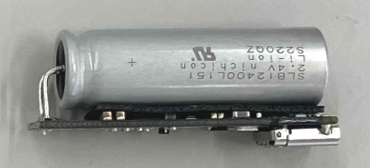Also, be careful not to short the SLB when cutting the leads, or soldering iron.

It is also possible to mount the SLB series in parallel with the board by bending the lead of the SLB series into an L-shape and inserting it into a through-hole on the mounting pad. In this case, make sure there is insulation below the SLB to prevent shorting the circuit on the board.

Fig 4-2-5

Example of the SLB parallel mounting

Step6. Attach the energy harvester

Solder the output wires of the energy harvester, such as a solar panel, to the mounting pads on the board. Be careful not to get the polarity wrong, and to use without exceeding the voltage of the input rating of this board. Also, do not directly connect a low impedance power supply source which has a capacity that exceeds the input rating of this board.

Step7. Attach the load circuit

Solder the load circuit to the LOAD mount pad. Be careful not to get the polarity wrong or create a short when soldering. Since it is directly connected to the SLB mount pad, energy is supplied to the load the moment it is connected.

All preparation is now complete.

* 1. **Initial settings and general information on the specifications**
* The LED charging indicator is a simple one that lights up when power is supplied from the USB path, and does not directly monitor the charging current to the SLB. The USB charging circuit will continue charging as long as the USB connection is established (once the SLB voltage reaches the overcharge protection level, it will enter a float charging state), so disconnect the USB cable at the appropriate time.
* If the battery is fully charged (preset value is 2.7V) via the energy harvesting path, the charging indicator may not light up when the USB cable is inserted. Even in this case, the DC/DC converter on the USB path is operating, the energy stored in the SLB may be consumed via the USB charging path. In this case, USB charging is not necessary, disconnect the USB cable.
* The energy harvesting PMIC used on this board has the characteristic that it is somewhat more efficient when used in buck mode than in boost mode. Therefore, if you use an energy harvesting element that can harvest at a voltage higher than the voltage range of the SLB, you can harvest energy more efficiently than if you use a harvesting element with a voltage lower than the SLB. However, be careful not to exceed the maximum input rating of the board.

For details on the PMIC, please refer to the AEM10300 datasheet.

<https://e-peas.com/product/aem10300-solar-battery-charger-up-to-7-cells/>

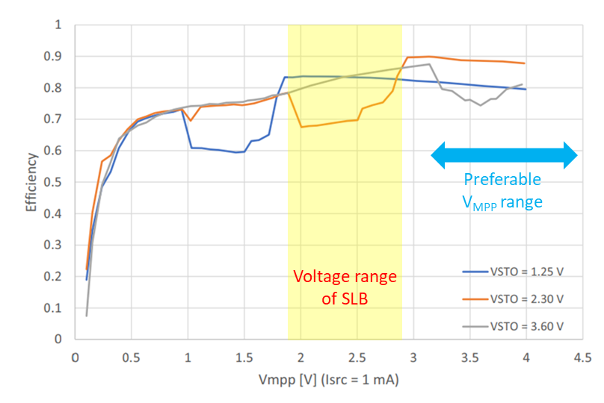

Fig 4-3 Harvesting efficiency of the PMIC (excerpt from datasheet, for reference)

Table 4-3 Initial setting of several parameters on the board

|  |  |  |  |
| --- | --- | --- | --- |
| Item | Parameter | Setting | Setting value |
| MPP ratio | R_MPP [2:0] | [1:0:0] | 80% |
| MPP sampling duration/period | T_MPP [1:0] | [0:1] | 70.8ms / 4.5s |
| PMIC power mode | EN_HP | [0] | Low power mode |
| Maximum charging voltage from energy harvesting path | STO_CFG [3:0] | [0:0:1:0] | 2.70V |
| Maximum charging voltage from USB path | R26 / R27 | 39.2kΩ / 11.5kΩ | 2.65V |
| Charging current setting resistor for USB path | R30 | 2Ω | 500mA @ 2.15V |
| SLB over-discharge protection | ― | Not implemented | Should be implemented outside of the board |

1. **Schematics**

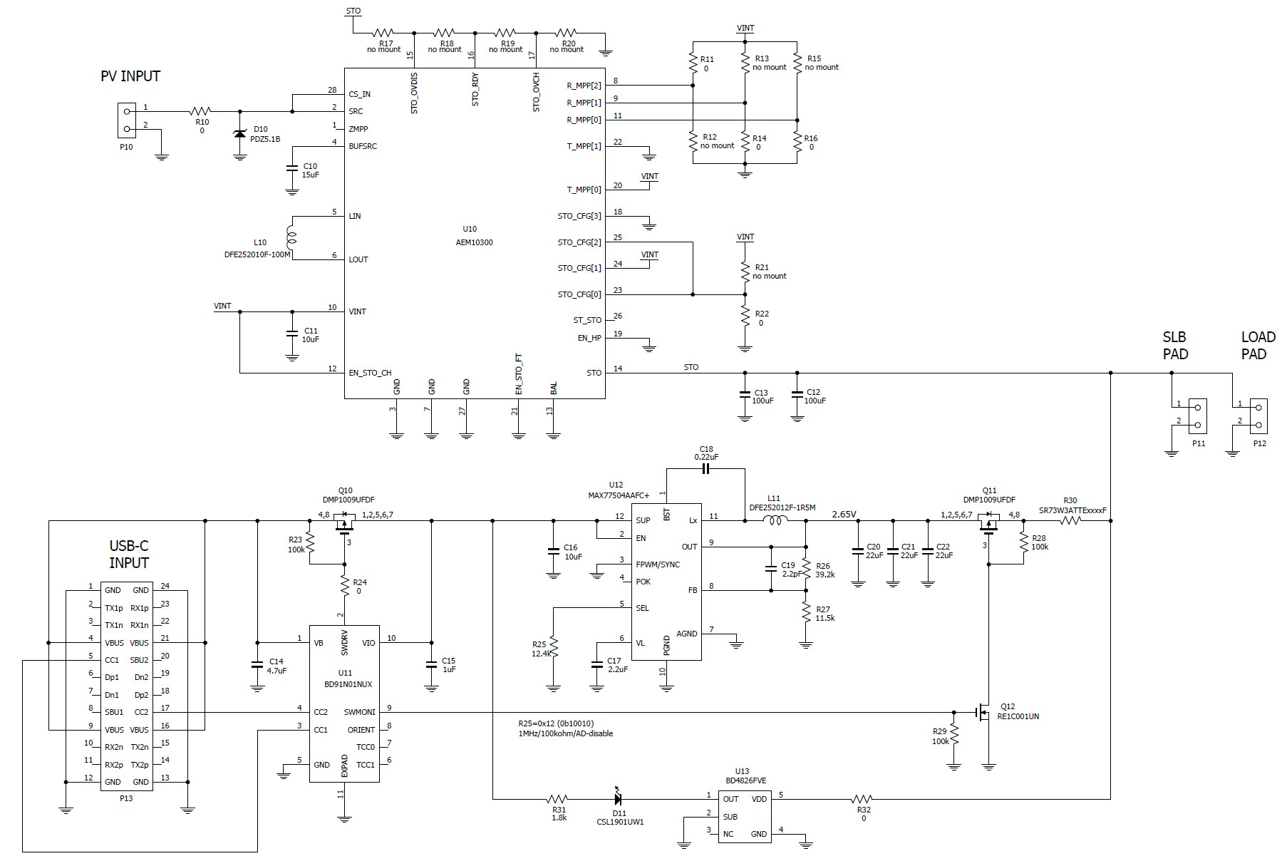

1. **Parts list**

Table 6 Parts list

|  |  |  |  |  |
| --- | --- | --- | --- | --- |
| Ref No. | Component | Value | Manufacturer | Description |
| C10 | Capacitor (0603) | 15uF | TDK | C1608X5R1A156M080AC |
| C11 | Capacitor (0603) | 10uF | Murata | GRM188R61A106KE69D |
| C12 | Capacitor (0805) | 100uF | Murata | GRM21BC80G107ME15L |
| C13 | Capacitor (0805) | 100uF | Murata | GRM21BC80G107ME15L |
| C14 | Capacitor (0603) | 4.7uF | Murata | GRM188R61E475KE11D |
| C15 | Capacitor (0603) | 1uF | Murata | GCM188R71C105KA64D |
| C16 | Capacitor (0603) | 10uF | Murata | GRM188R61A106KE69D |
| C17 | Capacitor (0603) | 2.2uF | Murata | GRM188R61E225KA12D |
| C18 | Capacitor (0603) | 220nF | Murata | GCM188R71H224KA64J |
| C19 | Capacitor (0603) | 2.2pF | Murata | GCM1885C2A2R2BA16D |
| C20 | Capacitor (0603) | 22uF | Murata | GRM188R61A226ME15J |
| C21 | Capacitor (0603) | 22uF | Murata | GRM188R61A226ME15J |
| C22 | Capacitor (0603) | 22uF | Murata | GRM188R61A226ME15J |
| D10 | Zener diode | 5.1V | Nexperia | PDZ5.1B |
| D11 | LED | Red | Rohm | CSL1901UW1 |
| L10 | Inductor (1008) | 10uH | Murata | DFE252010F-100M |
| L11 | Inductor (1008) | 1.5uH | Murata | DFE252012F-1R5M |
| P10 | PV solder pad | - | - | Need to solder an energy harvester |
| P11 | SLB solder pad | - | - | Need to solder an appropriate SLB |
| P12 | Load solder pad | - | - | Need to solder the power line of the load circuit |
| P13 | USB socket | Type-C | Amphenol | 12401610E4#2A |
| Q10 | MOSFET | p-ch | Diodes | DMP1009UFDF |
| Q11 | MOSFET | p-ch | Diodes | DMP1009UFDF |
| Q12 | MOSFET | n-ch | Rohm | RE1C001UNTCL |
| R10 | Resistor (0603) | Jumper | Vishay | CRCW06030000Z0EBC |
| R11 | Resistor (0603) | Jumper | Vishay | CRCW06030000Z0EBC |
| R12 | Resistor (0603) | Not mounted |  |  |
| R13 | Resistor (0603) | Not mounted |  |  |
| R14 | Resistor (0603) | Jumper | Vishay | CRCW06030000Z0EBC |
| R15 | Resistor (0603) | Not mounted |  |  |
| R16 | Resistor (0603) | Jumper | Vishay | CRCW06030000Z0EBC |
| R17 | Resistor (0603) | Not mounted |  | (*1) |
| R18 | Resistor (0603) | Not mounted |  | (*1) |
| R19 | Resistor (0603) | Not mounted |  | (*1) |
| R20 | Resistor (0603) | Not mounted |  | (*1) |
| R21 | Resistor (0603) | Not mounted |  | (*1) |
| R22 | Resistor (0603) | Jumper | Vishay | CRCW06030000Z0EBC (*1) |
| R23 | Resistor (0603) | 100kohm | KOA | RK73H1JTTD1003F |
| R24 | Resistor (0603) | Jumper | Vishay | CRCW06030000Z0EBC |
| R25 | Resistor (0603) | 12.4kohm | KOA | RK73H1JTTD1242F |
| R26 | Resistor (0603) | 39.2kohm | KOA | RK73H1JTTD3922F (*1) |

－ Table 6 Continued －

|  |  |  |  |  |
| --- | --- | --- | --- | --- |
| Ref No. | Component | Value | Manufacturer | Description |
| R27 | Resistor (0603) | 11.5kohm | KOA | RK73H1JTTD1152F (*1) |
| R28 | Resistor (0603) | 100kohm | KOA | RK73H1JTTD1003F |
| R29 | Resistor (0603) | 100kohm | KOA | RK73H1JTTD1003F |
| R30 | Resistor (2512) | 2ohm | KOA | SR73W3ATTE2R00F  (*2) Need to change to appropriate value resistor |
| R31 | Resistor (0603) | 1.8kohm | KOA | RK73H1JTTD1801F |
| R32 | Resistor (0603) | Jumper | Vishay | CRCW06030000Z0EBC |
| U10 | IC (PMIC) |  | e-peas | 10AEM10300C0000 |
| U11 | IC (USB-C detector) |  | Rohm | BD91N01NUX |
| U12 | IC (Buck DC/DC) |  | Analog Devices | MAX77504AAFC+ |
| U13 | IC (Voltage detector) |  | Rohm | BD4826FVE |

(*1) Need to change or install to appropriate resistors when using with SLB high temperature durable products.

(*2) Calculate the desired current value according to the using SLB and replace it as necessary.

**Revision history**

|  |  |  |
| --- | --- | --- |
| Revision No. | Date | Description |
| 0.8 | Mar. 4th, 2025 | Preliminary version |
| 0.9 | Mar.11th,2025 | Added solution for SLB high temperature durable products |
|  |  |  |
|  |  |  |