**Evaluation board for the SLB series for Series-Parallel Connection**

***EVSLB-SCAB01***

**User Guide**

**Description**

Nichicon "SLB” series are “Small Lithium Titanate Rechargeable Batteries” ideal for powering IoT systems. The EVSLB-SCAB01 is an evaluation board allows you to connect up to 6 SLB12400L151 units in any combination of series or parallel for evaluation. Each board is equipped with a cell balance circuit with overcharge/over discharge sensing and indicator for each cell. It can be configured with an output terminal that can be connected to a daughter board on the EVSLB-BUTI03.

Note: This board has been prepared for the purpose of easy evaluation of the SLB series’ characteristics at

research and development stage, and its quality cannot be guaranteed This board is not intended

to be used in products or any part thereof.

For product information on the SLB series, please refer to the following web page.

<https://nichiconbattery.com/>

**Features**

・Nichicon LTO battery: SLB12400L151 can be installed onto this board

The SLBs can be mounted easily without soldering thanks to the on-board sockets.

・Up to six SLBs can be connected in series or parallel by appropriate wiring the main terminal

・Overcharge / over-discharge detection circuit for each cell

(The detection signals of each cell are output by OR synthesis)

Over-discharge detection has a delay function (adjustable with a capacitor) that can be used to prevent malfunctions under pulse current loads

・Cell balancing circuit

The cell balance current can be set arbitrarily by changing resistors

Includes LED indicators for visual confirmation of circuit operation

・OV/CB signal terminals allow checking the overcharge and cell balance flags of each cell

・Daughter connection to EVSLB-BUTI03/EVSLB-BUAD04 is available

A backup power supply system using SLB as a storage element can be constructed without wiring

**Applications**

Power circuits that require higher voltages or larger storage capacity than single cell SLBs

Standalone energy harvesting power supply system with large intermittent load current,

5V/12V backup power supply, Disaster prevention infrastructure, Smart home, Wireless power receiving system etc.

1. **Specifications**

・Main Terminal (Input/Output): 14P / 1”pitch Pin header

[ Terminals connected to each cell: 3pin (V1N) to 14pin (V6P) ]

Allowable voltage and current specifications conform to SLB series specifications

per cell:

Charge/discharge current : DC up to 20C (SLB12400L151: 3.0A)

Voltage range : 2.8V to 1.8V

[ Overcharge/over-discharge flag terminal: 1pin (OVF) / 2pin (UVF) ]

MOSFET open drain output (Active L, reference level = V1N (3pin)

Set the external circuit so as not to exceed the MOSFET specifications (RE1J002YN: ROHM) (*)

・OV/CB Terminal (Output): 13P / 1”pitch Pin header

Outputs overcharge and cell balance flags for each cell

Overcharge flag : Active H

L level = Pulled down to V1N via resistor

H level = + voltage of the corresponding cell

Cell balance flag : Active L

L level = - voltage of the corresponding cell

H level = Pulled up to + voltage of the corresponding cell with 1MΩ

When using these signals, refer to the circuit diagram and handle with care for differences in voltage levels.

・Overcharge/over-discharge detection circuit (*)

Overcharge:

detection voltage: 2.75V; release voltage: 2.65V

Over-discharge:

detection voltage: 1.80V, detection delay time: approx. 5.5sec; release voltage: 1.89V

・Cell balancing circuit (*)

Cell balancing start voltage : 2.65V

Cell balancing release voltage : 2.60V

Cell balancing current : User-settable using Rx9 (x=g to L)

(An additional current of about 2mA flows to light the LED indicator during cell balancing)

・Dimensions: 45mm×56mm×12mm

(*) Please refer to individual datasheets for details.

　Small Lithium Titanate Rechargeable Battery ”SLB” series (Nichicon)

<https://nichiconbattery.com/>

Voltage monitoring IC with sell balancing function : S-19190 (ABLIC)

<https://www.ablic.com/en/doc/datasheet/automotive_battery_protection/S19190_E.pdf>

Voltage detector : S-1009 (ABLIC)

<https://www.ablic.com/en/doc/datasheet/voltage_detector/S1009_E.pdf>

MOSFET for cell balancing : DMP1245UFCL (Diodes)

<https://www.diodes.com/datasheet/download/DMP1245UFCL.pdf>

Small signal MOSFET : RE1J002YN (ROHM)

<https://fscdn.rohm.com/en/products/databook/datasheet/discrete/transistor/mosfet/re1j002yntcl-e.pdf>

1. 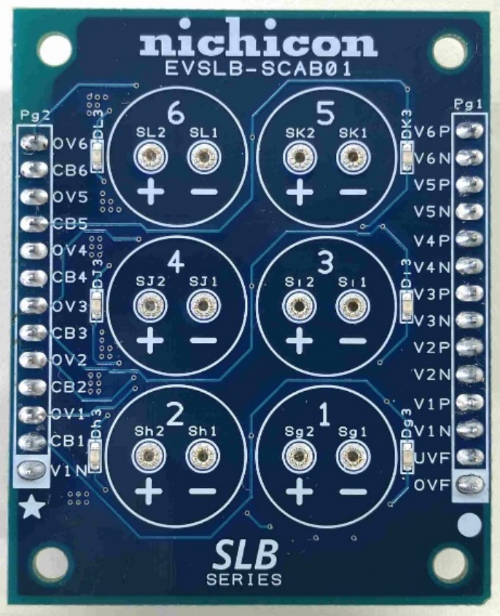**Appearance and user interfaces**

**6**

**6**

**6**

**6**

**6**

**6**

**4**

**5**

**7**

**7**

3

1

2

Fig 2-1 Front Side

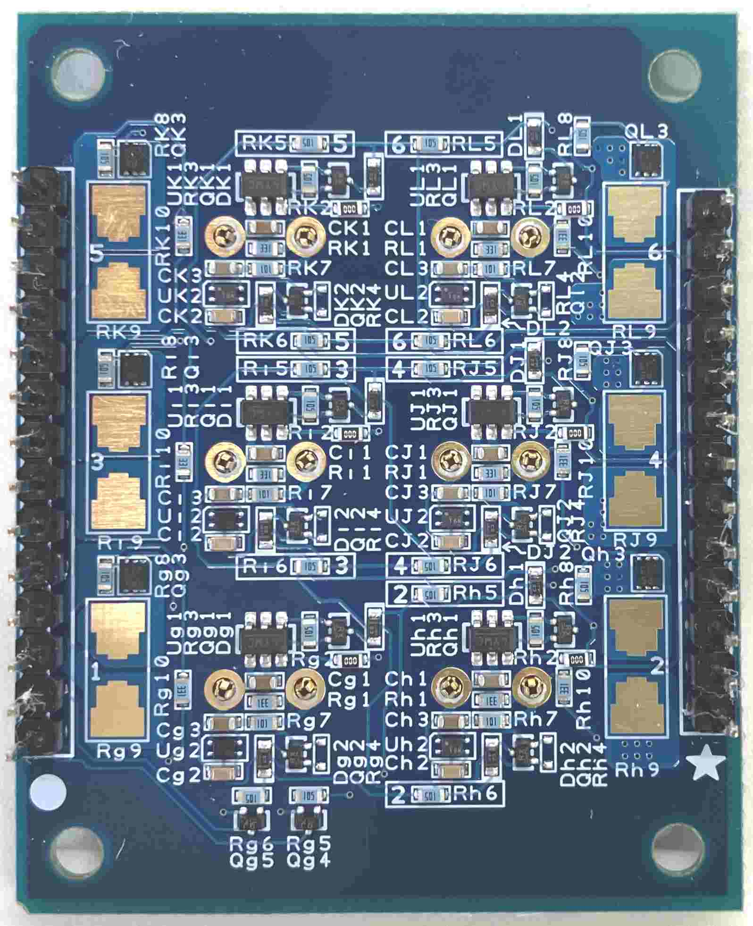

**8**

**8**

**8**

**10**

**9**

**10**

**8**

**8**

**9**

**10**

**9**

**8**

1

2

3

**4**

**7**

**7**

Fig 2-2 Back Side

Table2-1 Functions of each part

|  |  |  |  |
| --- | --- | --- | --- |
| No. | Name | Ref-No. | Description |
| 1 | Main terminal  1pin | Pg1  OVF | Overcharge flag output  (n-ch MOSFET open drain, V1N reference, Active L)  If overcharge is detected in any of the cells used, this pin outputs Low (V1N). If overcharge is not detected, this pin becomes open.  Use by pulling up to any voltage. Leave it open if not used.  *Please set the external circuit so that it is within the rating of the output MOSFET. |
| 2 | Main terminal  2pin | Pg1  UVF | Over-discharge flag output  (n-ch MOSFET open drain, V1N reference, Active L)  If over-discharge is detected in any of the cells used, this pin outputs Low (V1N). If over-discharge is not detected, this pin becomes open.  Use by pulling up to any voltage. Leave it open if not used.  *Please set the external circuit so that it is within the rating of the output MOSFET. |
| 3 | Main terminal  3pin to 14pin | Pg1  VnN/VnP  (n=1 to 6) | Terminals are connected to the negative (VnN) and positive (VnP) sides of each cell (n=1 to 6), where n corresponds to the mounting location number of the SLB silk-screened on the board. By connecting these terminals appropriately, any series-parallel connection can be configured for up to six SLBs. Pull out the wiring to the load circuit and charging circuit from the appropriate points of these terminals.  For instructions on configuring a series-parallel circuit, see ***4.2 Board Setup and Usage Instructions***. |
| 4 | OV/CB terminal | Pg2 | Output terminal can monitor the overcharge flag and cell balance flag of each cell. Do not apply voltage or signals from outside.  If the SLB is configured in series connection, the H/L levels output from each cell will differ, you need to handle this with care.  Leave this terminal open if not using these signals. |
| 5 | SLB  mounting position | Sx1/Sx2  (x=g to L) | Install SLB12400L151 in this location.  Insert the lead wires into the socket holes, paying close attention to the polarity (Sx1: - side, Sx2: + side, x=g to L). No soldering is required.  When removing the SLB, pull it straight up so as not to put stress on the leads.  If you are using less than six SLBs, using them in order from lowest to highest silk screen number simplifies the work required to optimize the protection circuit. For details, see ***4.2 Board Setup and Usage Instructions***. |

* Table 2-1 Continued -

|  |  |  |  |
| --- | --- | --- | --- |
| No. | Name | Ref-No. | Description |
| 6 | Cell balancing  indicator | Dx3  (x=g to L) | When the SLB cell voltage is within the cell balancing voltage range (2.65V or higher when the voltage is rising, and 2.60V or higher when the voltage is falling), the LED indicator (red) located next to the SLB mounting position will light up. When the SLB cell voltage is outside the cell balancing voltage range, the LED indicator will turn off.  For details, see ***4.2 Board Setup and Usage Instructions.*** |
| 7 | Alignment marks | ★ / ● | When used in combination with EVSLB-BUTI03/EVSLB-BUAD04, you can configure a backup power supply without external wiring by inserting the pin header of this board into the header socket of those boards so that the ★/● marks silk-screened near the connectors on both sides of those boards are in the same position. |
| 8 | Cell balancing  resistor | Rx9  (x=g to L) | The location to implement the resistor that controls the cell balancing current.  Mount an appropriate resistor that can limit the desired cell balancing current.  For details on the settings, refer to ***4.2*** ***Board Setup and Usage Instructions.*** |
| 9 | Overcharge /  over-discharge signal transmission resistor | Rx5/Rx6  (x=g to L) | These resistors are used to level-shift the overcharge and over-discharge flags detected in each cell to form an OR circuit. The resistor connection needs to be optimized so that the detection signal is transmitted correctly according to the SLB connection configuration.  For details on the settings, see ***4.2 Board Setup and Usage Instructions.*** |
| 10 | Over-discharge detection delay time setting capacitor | Cx2  (x=g to L) | This capacitor sets the delay time from when the cell voltage falls below the over-discharge detection threshold voltage until the over-discharge flag is issued. It can be used to adjust the sensitivity of the detection circuit to momentary voltage drops caused by the battery's internal resistance. By setting the delay time appropriately, it is possible to suppress unintended operation of the protection circuit when a large pulsed current is required on the load side.  For details, see ***4.2 Board Setup and Usage Instructions*** and S-1009 datasheet. |

1. 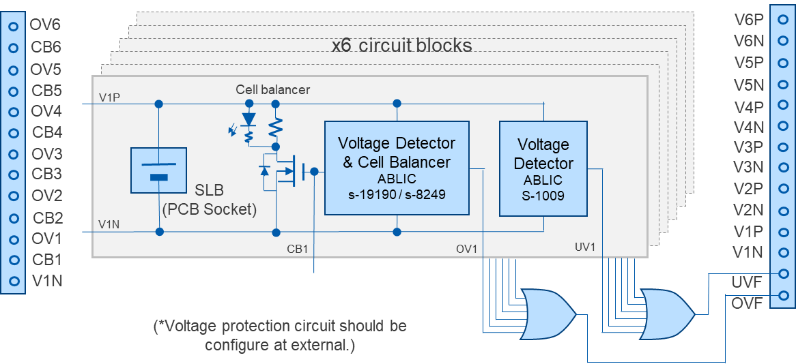**Circuit configuration**

Fig 3-1 Circuit configuration and functional block diagram

1. **Usage guidance**

**4.1 Precautions for use**

* Before installing the SLB, complete the necessary component mounting and wiring (wiring the main connection terminals, installing cell balance resistors, optimizing the overcharge/over-discharge signal transmission circuit, etc.). If you do it with the SLB installed, there is a risk of electric shock, or damage to circuit components due to unintentional short circuits, etc.
* When installing the SLB, pay close attention to the polarity. This board does not have a protection function against reverse polarity insertion of SLB, so installing it with the wrong polarity will damage the circuit.
* Do not short-circuit the load/charging circuit connection wires or the +/- terminals of each SLB cell. This may not only damage or deteriorate the SLB performance, but may also damage the board and surrounding circuits and cause smoke.
* This board does not have a current cutoff function, so basically an external switch circuit or similar is required to stop overcharging and over-discharging. If overcharging and over-discharging can be avoided by the operating specifications of the external circuit, those protection devices are not necessarily required, but please consider carefully before deciding whether or not to include a protection circuit.
* Do not input an external voltage or signal to the OV/CB terminal, as this may cause the circuit to malfunction or be damaged.
* Pay attention to the GND potential of all connected circuits and measuring instruments. When multiple SLBs are connected in series, the reference voltages of each cell and the control circuits connected to each cell are not all the same, so you need to pay attention to the differences in voltage levels when observing and using input and output signals.

**4.2 Board Setup and Usage Instructions**

**Step1. Wiring of SLB series/parallel connection**

Connect the corresponding terminals of connector Pg1 according to the configuration of the SLB series you want to connect (for example, 5 in series (=5S1P), 2 in series, 2 in parallel (=2S2P), etc.). If you use the SLB series inserted into block 1 of circuit blocks 1 to 6 in ascending order of number as the bottom cell, you can easily customize the required protection circuit (step2 on the next).

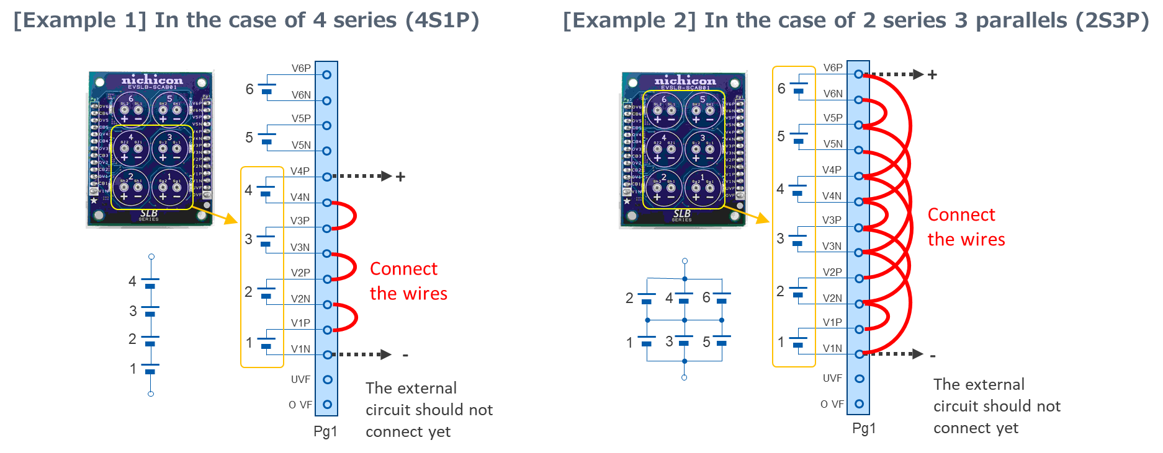

Fig 4-2-1 Example of wiring Pg1

**Step2. Optimization of overcharge/over-discharge detection circuit**

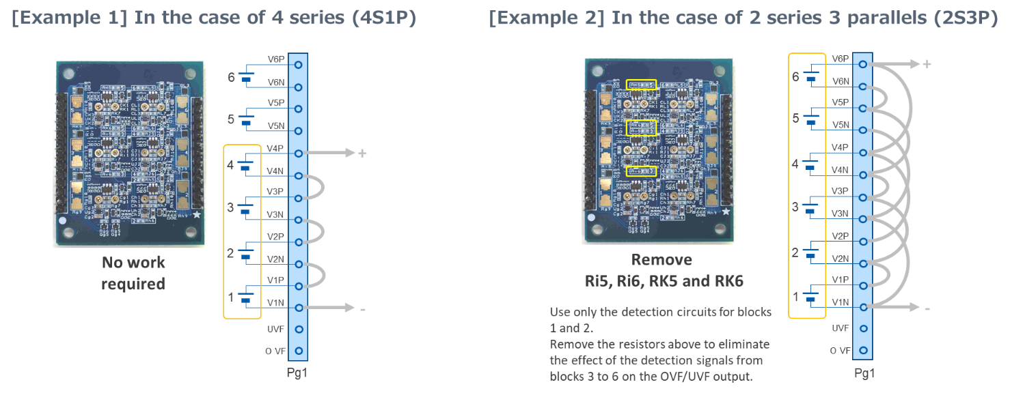The circuit configuration is needed to be optimized so that the overcharge/over-discharge signal circuit operates properly according to the connection configuration of the SLB series. This is done by removing the appropriate resistors (Rx5/Rx6, x=h to L), but this is not necessary if it is a simple series connection (2S1P to 6S1P) without parallel connection.

Fig 4-2-2 Overcharge/over-discharge signal circuit setting example

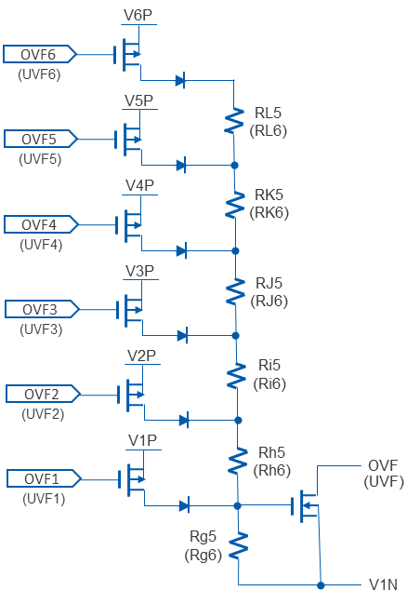

Fig 4-2-3 Configuration of overcharge/over-discharge signal transmission circuit

**Step3. Setting of cell balancing current**

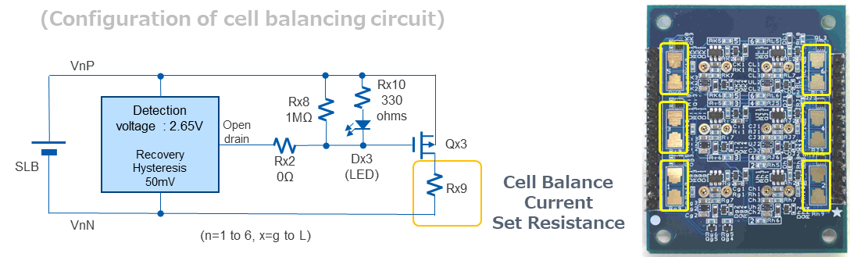Calculate the resistance value to get the desired cell balancing current to flow by using the formula below, and mount it on Rx9 (x=g to L) of the circuit block to be used. The mounting pads are compatible with sizes 0805 to 2512 (in inches).

**Rx9 [Ω] = 2650 ／ ICB(start) [mA]**

Fig 4-2-4 Cell balancing circuit

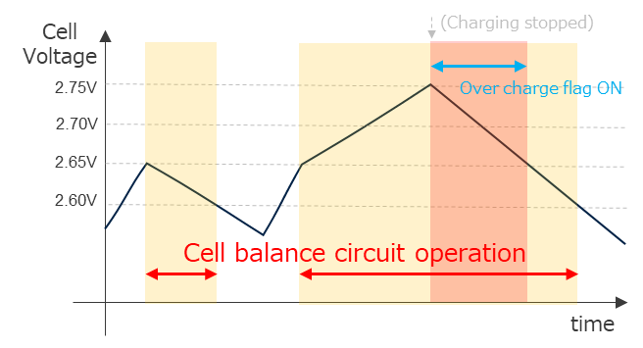

For details on how the cell balancing function works, please refer to the following datasheet.

ABLIC S-19190 datasheet:

[https://www.ablic.com/en/doc/datasheet/automotive_](https://www.ablic.com/en/doc/datasheet/automotive_battery_protection/S19190_E.pdf)

[battery_protection/S19190_E.pdf](https://www.ablic.com/en/doc/datasheet/automotive_battery_protection/S19190_E.pdf)

Fig 4-2-5 Cell balancing operation

* The cell balancing current varies depending on the voltage of the corresponding cell.

When charging is stopped by using the OVF signal of this board, the maximum cell balancing current is 2750/Rx9 [mA]. ​​The minimum cell balancing current is 2600/Rx9 [mA].

To be precise, the cell balancing current value is set including the on-resistance of Qx3, but since the on-resistance of the MOSFET used in this circuit is 50mΩ or less, it will be no problem if you ignore the on-resistance when the cell balancing current is within the range of the commonly used value.

* During cell balancing, power consumption at Rx9 corresponds to the square of the cell balancing current

value multiplied by the resistance value, so care should be taken to prevent heat generation, etc., especially when the cell balancing current value is large.

When parallel connections are involved, it will work with only one cell balancing resistor among the parallel elements, but the temperature gradient will be smaller if all resistors are used to distribute the power consumption.

* If cell balancing is not required, Rx9 does not need to be mounted with a resistor.

However, in the default state, a few mA of current flows to drive the LED when the cell balance voltage level is detected, and this plays a small role in adjusting the cell balance. If you do not need this current, remove Rx2 (Jumper chip).

(in this case the cell balance indicator will not function)

**Step4. Setting of over-discharge flag delay time**

Using the detection delay function of the overdischarge detection IC, it may be possible to reduce unintended operation stops due to over-discharge detection during large current pulse loads. The delay time can be changed by changing the constant of capacitor Cx2 (x=g to L) as necessary. (Initial setting: approx. 5.5 sec)

For details, please refer to the following data sheet.

ABLIC S-1009 datasheet:

<https://www.ablic.com/en/doc/datasheet/voltage_detector/S1009_E.pdf>

**Step5. External circuit configuration**

This board has an overcharge/over-discharge detection function, but does not have a current cutoff function, so an external switch circuit or similar is required to stop overcharge or over-discharge. Please configure an appropriate circuit and insert it into the charge path (and/or) discharge path.

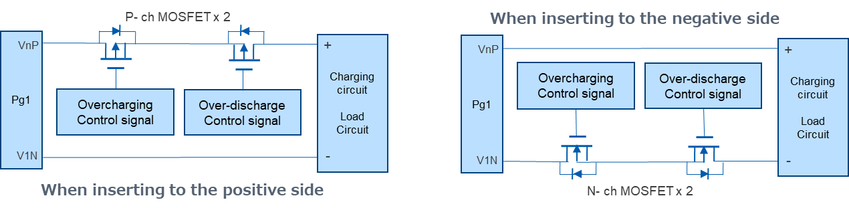

Fig 4-2-6 Example of the external switch circuit

* To prevent power being unexpectedly supplied when inserting the SLB series into the board,

it is preferable to:

Either keep the overcharge/over-discharge protection switch device OFF until the device is in use (for example, in the circuit shown above, short out the gate and source of each MOSFET)

or

Install a separate switch between the charging circuit and load circuit.

* When using a circuit like the one shown above, be careful not to impair the protection function by the

wiring of the device that controls the current cut-off MOSFET. In particular, if you insert a protection device on the negative side, you may need to devise a way to exchange signals between this board and the connected circuit, since the current is cut off by cutting the GND between this board and the connected circuit when the protection function is on.

* OVF/UVF signal (open drain output with a reference level V1N, ON when detected / Hi-Z when not

detected ) output from this board can also be used as the overcharge/over-discharge control signal . Please take the above into consideration when configuring a circuit that will allow the current cutoff switch to operate properly.

* If overcharging and over-discharging can be avoided by the operating specifications of the external

circuit, a protection device is not necessarily required, but please consider carefully before deciding whether or not to include a protection circuit.

**Step6. Installing the SLB**

Insert the SLB12400L151 into the onboard socket of the circuit block to be used. When inserting, be sure to pay close attention to the polarity. (There is no protection against incorrect polarity insertion.)

This completes the preparation.

If you remove the measure to prevent unintended power supply in step 4, the connected circuit will start operating.

**4.3 Initial settings**

Table 4-3-1 Voltage detection specifications at initial setting, etc.

|  |  |  |  |  |
| --- | --- | --- | --- | --- |
| Item | | Setting  value | Min.  value | Max.  value |
| Cell balancing start voltage (when voltage rises) | | 2.65V | 2.64V | 2.66V |
| Cell balancing end voltage (when voltage drops) | | 2.60V | 2.57V | 2.63V |
| Over charge detection start voltage (when voltage rises) | | 2.75V | 2.74V | 2.76V |
| Over charge detection release voltage (when voltage drops) | | 2.65V | 2.62V | 2.68V |
| Over discharge detection start voltage (when voltage drops) | | 1.80V | 1.79V | 1.81V |
| Over discharge detection release voltage (when voltage rises) | | 1.89V | 1.87V | 1.91V |
| Delay time of over-discharge detection | | 5.5s | 4.7s | 6.2s |
| Current consumption | During normal operation  (overcharge/over-discharge not detected,  cell balancing circuit not operating) | Approx.  3.5μA | ― | ― |
| When the cell balance circuit is operating (overcharge not detected)  * | Approx.  2.5mA  @2.65V | ― | ― |
| When overcharge is detected (cell balancing circuit also operates)  * | Approx.  2.8mA  @2.75V | ― | ― |
| When over-discharge is detected | Approx.  17μA  @1.80V | ― | ― |

* If a cell balance current is set in Rx9, that current is added

1. 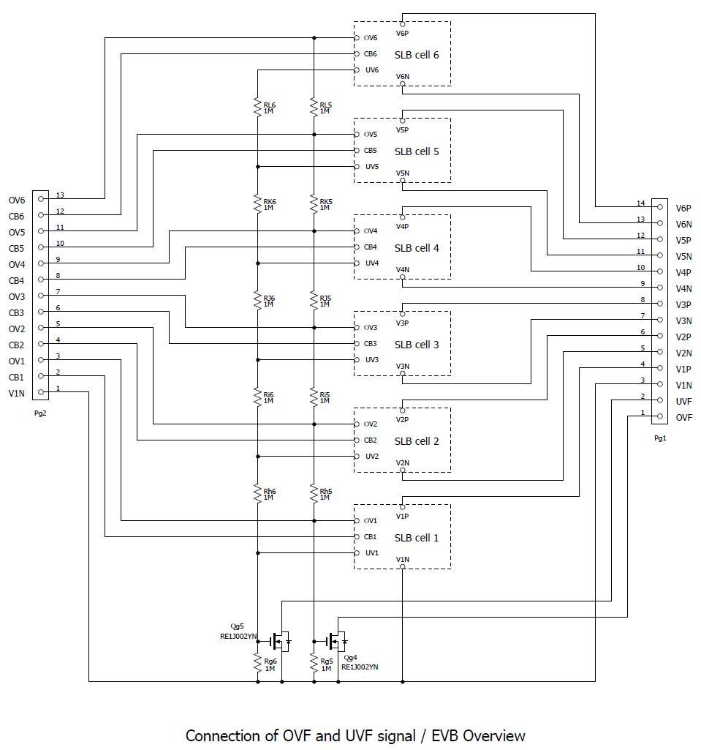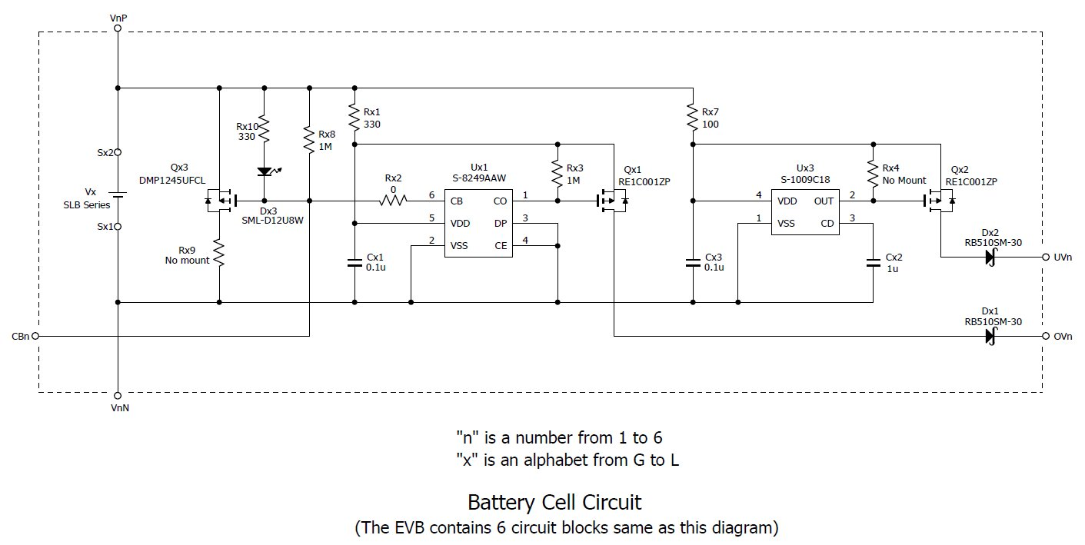**Schematics**
2. **Parts list**

Table 6 Parts list

|  |  |  |  |  |
| --- | --- | --- | --- | --- |
| Ref No. | Component | Value | Manufacturer | Description |
| Cx1 | Capacitor (0603) | 100nF | Murata | GCJ188R71H104KA12D |
| Cx2 | Capacitor (0603) | 1uF | Murata | GCM188R71C105KA64D |
| Cx3 | Capacitor (0603) | 100nF | Murata | GCJ188R71H104KA12D |
| Dx1 | Schottky barrier diode |  | Rohm | RB510SM-30T2R |
| Dx2 | Schottky barrier diode |  | Rohm | RB510SM-30T2R |
| Dx3 | LED | Red | Rohm | SML-D12U8WT86 |
| Pg1 | Pin header | 14pin | Adam Tech | PH1-14-UA |
| Pg2 | Pin header | 13pin | Adam Tech | PH1-13-UA |
| Qx1 | MOSFET | p-ch | Rohm | RE1C001ZPTL |
| Qx2 | MOSFET | p-ch | Rohm | RE1C001ZPTL |
| Qx3 | MOSFET | p-ch | Diodes | DMP1245UFCL-7 |
| Qg4 | MOSFET | n-ch | Rohm | RE1J002YNTCL |
| Qg5 | MOSFET | n-ch | Rohm | RE1J002YNTCL |
| Sx1 | Through hole socket |  | Mac8 | AF-0.7(H) |
| Sx2 | Through hole socket | - | Mac8 | AF-0.7(H) |
| Ux1 | IC (Voltage detector, cell balancer) |  | ABLIC | S-8249AAW-M6T1U *2 |
| Ux2 | IC (Voltage detector) |  | ABLIC | S-1009C18I-I4T1U |
| Rx1 | Resistor (0603) | 330ohm | KOA | RK73H1JTTD3300F |
| Rx2 | Resistor (0603) | Jumper | Vishay | CRCW06030000Z0EBC |
| Rx3 | Resistor (0603) | 1Mohm | KOA | RK73H1JTTD1004F |
| Rx4 | Resistor (0603) | Not mounted |  |  |
| Rx5 | Resistor (0603) | 1Mohm | KOA | RK73H1JTTD1004F |
| Rx6 | Resistor (0603) | 1Mohm | KOA | RK73H1JTTD1004F |
| Rx7 | Resistor (0603) | 100ohm | KOA | RK73H1JTTD1000F |
| Rx8 | Resistor (0603) | 1Mohm | KOA | RK73H1JTTD1004F |
| Rx9 | Resistor (2512) | → | → | Need to mount an appropriate value resistor |
| Rx10 | Resistor (0603) | 330ohm | KOA | RK73H1JTTD3300F |

*1 　 "x" is any of g, h, I, J, K, or L (all six circuit blocks have the same circuit configuration and constants).

*2 　 S-8249AAW is an EOL part.

An alternative part with the same voltage control specifications is the S-19190AWH (ABLIC).

The S-19190BJH can also be used as an alternative (the control voltage threshold is slightly different).

**Revision history**

|  |  |  |
| --- | --- | --- |
| Revision No. | Date | Description |
| 0.80 | Nov.8th, 2024 | Preliminary version |
| 1.00 | Nov.27th, 2024 | Release version |
|  |  |  |
|  |  |  |