**Evaluation board for the SLB series for Series-Parallel Connection**

***EVSLB-SCTR02***

**User Guide**

**Description**

Nichicon "SLB” series are “Small Lithium Titanate Rechargeable Batteries” ideal for powering IoT systems. The EVSLB-SCTR02 is an evaluation board allows you to connect up to 6 SLB12400L151 units in any combination of series or parallel for evaluation~~.~~ Each evaluation board is equipped with a cell balance circuit with overcharge/over discharge sensing and indicator for each cell. A product that can be configured with an output terminal that can be connected to a daughter board on the EVSLB-BUTI03.

Note: This board has been prepared for the purpose of easy evaluation of the SLB series’ characteristics at the

research and development stage and its quality cannot be guaranteed. This board is not intended

to be used in products or any part thereof.

For product information on the SLB series, please refer to the following web page.

<https://nichiconbattery.com/>

**Features**

・Nichicon LTO battery: SLB12400L151 can be installed onto this board

The SLBs can be mounted easily without soldering~~,~~ thanks to the on-board socket

・Up to six SLBs can be connected in series or parallel by appropriate wiring the main terminal

・Overcharge / over-discharge detection circuit for each cell

The control threshold voltage (detection start/release) can be set arbitrarily by changing resistors

(The detection signals of each cell are output by OR synthesis)

・Cell balancing circuit

The control threshold voltage (cell balancing start/release) can be set arbitrarily by changing resistors

The cell balance current can be set arbitrarily by changing resistors

Includes LED indicators for visual confirmation of circuit operation

・OV/CB signal terminals allow checking the overcharge and cell balance flags of each cell

・Daughter connection to EVSLB-BUTI03/EVSLB-BUAD04 is available

A backup power supply system using SLB as a storage element can be constructed without wiring

**Applications**

Power circuits that require higher voltages or larger storage capacity than single cell SLBs.

Standalone energy harvesting power supply system with large intermittent load current,

5V/12V backup power supply, Disaster prevention infrastructure, Smart home, Wireless power receiving system etc.

1. **Specifications**

・Main Terminal (Input/Output): 14P / 1”pitch Pin header

[ Terminals connected to each cell: 3pin (V1N) to 14pin (V6P) ]

Allowable voltage and current specifications conform to SLB series specifications

per cell:

Charge/discharge current : DC up to 20C (SLB12400L151: 3.0A)

Voltage range : 2.8V to 1.8V

[ Overcharge/over-discharge flag terminal: 1pin (OVF) / 2pin (UVF)]

MOSFET open drain output (Active L, reference level = V1N (3pin) )

Set the external circuit so as not to exceed the MOSFET specifications (RE1J002YN: ROHM) (*)

・OV/CB Terminal (Output): 13P / 1”pitch Pin header

Outputs overcharge and cell balance flags for each cell

Overcharge flag : Active L

L level = - voltage of the corresponding cell

H level = Pulled up to + voltage of the corresponding cell with 1MΩ

Cell balance flag : Active L

L level = - voltage of the corresponding cell

H level = Pulled up to + voltage of the corresponding cell with cell balancing resistor

When using these signals, refer to the circuit diagram and handle with care for differences in voltage levels.

・Overcharge/over-discharge detection circuit (Initial settings) (*)

Overcharge:

detection voltage: 2.78V; release voltage: 2.71V

Over-discharge:

detection voltage: 1.80V; release voltage: 2.19V

・Cell balancing circuit (Initial settings) (*)

Cell balancing start voltage : 2.66V

Cell balancing release voltage : 2.60V

Cell balancing current : User-settable using Rx13 (x=A to F)

(An additional current of about 2mA flows to light the LED indicator during cell balancing)

・Dimensions: 45mm×56mm×12mm

(*) Please refer to individual datasheets for details.

　Small Lithium Titanate Rechargeable Battery ”SLB” series (Nichicon)

<https://nichiconbattery.com/>

Voltage detector: XC6135 (TOREX)

<https://product.torexsemi.com/system/files/series/xc6135.pdf>

MOSFET for cell balancing: DMN1019UFDE (Diodes)

<https://www.diodes.com/assets/Datasheets/DMN1019UFDE.pdf>

Small signal MOSFET: RE1J002YN (ROHM)

<https://fscdn.rohm.com/en/products/databook/datasheet/discrete/transistor/mosfet/re1j002yntcl-e.pdf>

1. **Appearance and user interfaces**

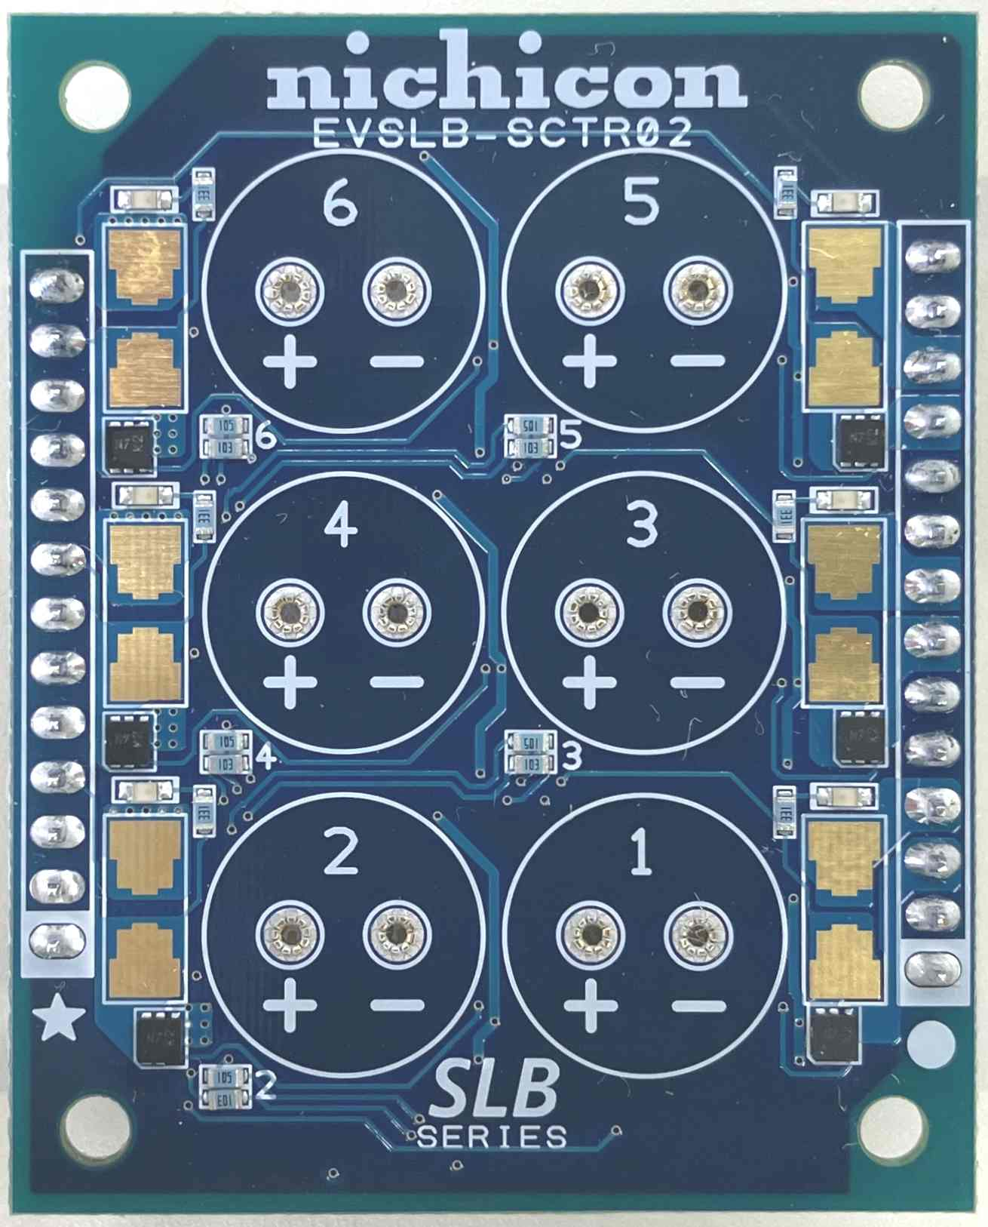

**7**

**9**

**9**

**9**

**8**

**8**

**8**

**8**

**8**

**8**

**6**

**6**

**6**

**6**

**6**

**6**

2

1

**4**

**5**

**7**

3

**4**

Fig 2-1 Front Side

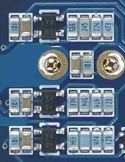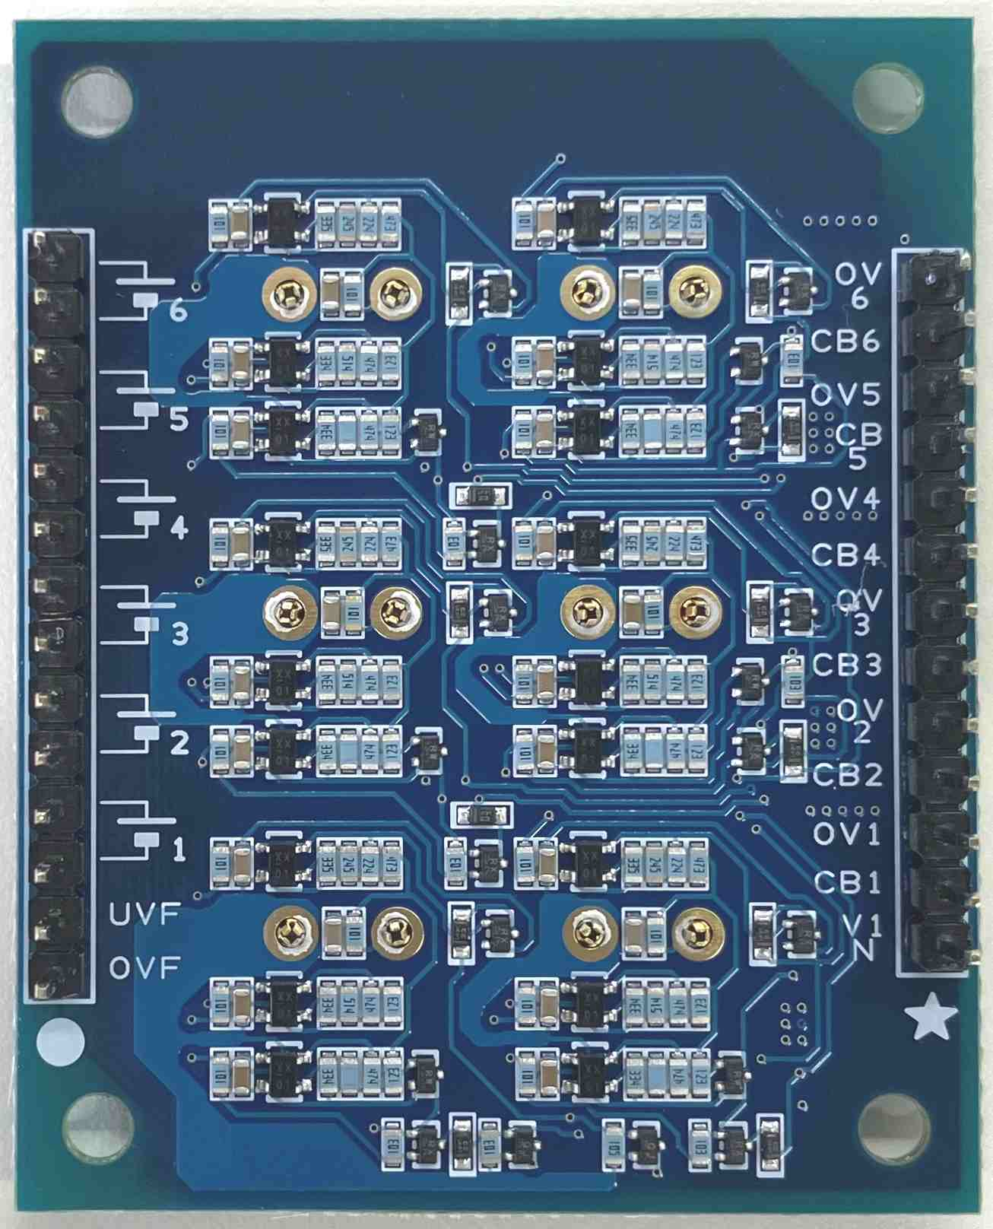

The component layout

of the other five circuit blocks

is the same

**10**

**11**

**12**

**4**

3

2

1

**7**

**7**

Fig 2-2 Back Side

Table2-1 Functions of each part

|  |  |  |  |
| --- | --- | --- | --- |
| No. | Name | Ref-No. | Description |
| 1 | Main terminal  1pin | PA1  OVF | Overcharge flag output  (n-ch MOSFET open drain, V1N reference, Active L)  If overcharge is detected in any of the cells used, this pin outputs Low (V1N). If overcharge is not detected, this pin becomes open.  Use by pulling up to any voltage. Leave it open if not used.  *Please set the external circuit so that it is within the rating of the output MOSFET. |
| 2 | Main terminal  2pin | PA1  UVF | Over-discharge flag output  (n-ch MOSFET open drain, V1N reference, Active L)  If over-discharge is detected in any of the cells used, this pin outputs Low (V1N). If over-discharge is not detected, this pin becomes open.  Use by pulling up to any voltage. Leave it open if not used.  *Please set the external circuit so that it is within the rating of the output MOSFET. |
| 3 | Main terminal  3pin to 14pin | PA1  VnN/VnP  (n=1 to 6) | Terminals are connected to the negative (VnN) and positive (VnP) sides of each cell (n=1 to 6), where n corresponds to the mounting location number of the SLB silk-screened on the board. By connecting these terminals appropriately, any series-parallel connection can be configured for up to six SLBs. Pull out the wiring to the load circuit and charging circuit from the appropriate points of these terminals.  For instructions on configuring a series-parallel circuit, see ***4.2 Board Setup and Usage Instructions***. |
| 4 | OV/CB terminal | PA2 | Output terminal can monitor the overcharge flag and cell balance flag of each cell. Do not apply voltage or signals from outside.  If the SLB is configured in series connection, the H/L levels output from each cell will differ, you need to handle this with care.  Leave this terminal open if not using these signals. |
| 5 | SLB  mounting position | Sx1/Sx2  (x=A to F) | Install SLB12400L151 in this location.  Insert the lead wires into the socket holes, paying close attention to the polarity. No soldering is required.  When removing the SLB, pull it straight up so as not to put stress on the leads.  If you are using less than six SLBs, using them in order from lowest to highest silk screen number simplifies the work required to optimize the protection circuit. For details, see ***4.2 Board Setup and Usage Instructions***. |

*Please refer to the attached parts layout board for reference numbers.

* Table 2-1 Continued -

|  |  |  |  |
| --- | --- | --- | --- |
| No. | Name | Ref-No. | Description |
| 6 | Cell balancing  indicator | Dx1  (x=A to F) | When the SLB cell voltage is within the cell balancing voltage range (2.66V or higher when the voltage is rising, and 2.60V or higher when the voltage is falling), the LED indicator (red) located next to the SLB mounting position will light up. When the SLB cell voltage is outside the cell balancing voltage range, the LED indicator will turn off.  For details, see ***4.2 Board Setup and Usage Instructions.*** |
| 7 | Alignment marks | ★ / ● | When used in combination with EVSLB-BUTI03/EVSLB-BUAD04, you can configure a backup power supply without external wiring by inserting the pin header of this board into the header socket of those boards so that the ★/● marks silk-screened near the connectors on both sides of those boards are in the same position. |
| 8 | Cell balancing  resistor | Rx13  (x=A to F) | The location to implement the resistor that controls the cell balancing current.  Mount an appropriate resistor that can limit the desired cell balancing current.  For details on the settings, refer to ***4.2*** ***Board Setup and Usage Instructions.*** |
| 9 | Overcharge /  over-discharge signal transmission resistor | Rx20/Rx21  (x=A to F) | These resistors are used to level-shift the overcharge and over-discharge flags detected in each cell to form an OR circuit. The resistor connection needs to be optimized so that the detection signal is transmitted correctly according to the SLB connection configuration.  For details on the settings, see ***4.2 Board Setup and Usage Instructions.*** |
| 10 | Resistor for setting the over-discharge detection threshold | Rx16 to Rx19  (x=A to F) | This resistor sets the operating threshold of the over-discharge detection circuit. You can set any operating threshold by changing the resistance.  For details, see ***4.2 Board Setup and Usage Instructions***. |
| 11 | Resistor for setting the cell balancing threshold | Rx9 to Rx12  (x=A to F) | This resistor sets the operating threshold of the cell balancing circuit. You can set any operating threshold by changing the resistance.  For details, see ***4.2 Board Setup and Usage Instructions***. |
| 12 | Resistor for setting the overcharge detection threshold | Rx3 to Rx6  (x=A to F) | This resistor sets the operating threshold of the overcharge detection circuit. You can set any operating threshold by changing the resistance.  For details, see ***4.2 Board Setup and Usage Instructions***. |

1. **Circuit configuration**

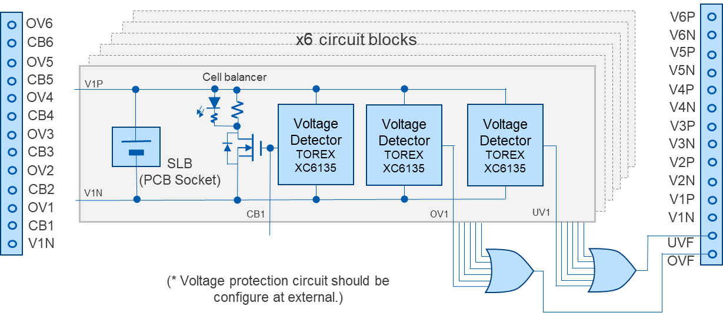

Fig 3-1 Circuit configuration and functional block diagram

1. **Usage guidance**

**4.1 Precautions for use**

* Before installing the SLB, complete the necessary component mounting and wiring (wiring the main connection terminals, installing cell balance resistors, optimizing the overcharge/over-discharge signal transmission circuit, etc.). If you do it with the SLB installed, there is a risk of electric shock, or damage to circuit components due to unintentional short circuits, etc.
* When installing the SLB, pay close attention to the polarity. This board does not have a protection function against reverse polarity insertion of SLB, so installing it with the wrong polarity will damage the circuit.
* Do not short-circuit the load/charging circuit connection wires or the +/- terminals of each SLB cell. This may not only damage or deteriorate the SLB performance, but may also damage the board and surrounding circuits and cause smoke.
* This board does not have a current cutoff function, so basically an external switch circuit or similar is required to stop overcharging and over-discharging. If overcharging and over-discharging can be avoided by the operating specifications of the external circuit, those protection devices are not necessarily required, but please consider carefully before deciding whether or not to include a protection circuit.
* Do not input an external voltage or signal to the OV/CB terminal, as this may cause the circuit to malfunction or be damaged.
* Pay attention to the GND potential of all connected circuits and measuring instruments. When multiple SLBs are connected in series, the reference voltages of each cell and the control circuits connected to each cell are not all the same, so you need to pay attention to the differences in voltage levels when observing and using input and output signals.

**4.2 Board Setup and Usage Instructions**

**Step1. Wiring of SLB series/parallel connection**

Connect the corresponding terminals of connector Pg1 according to the configuration of the SLB series you want to connect (for example, 5 in series (=5S1P), 2 in series, 2 in parallel (=2S2P), etc.). If you use the SLB series inserted into block 1 of circuit blocks 1 to 6 in ascending order of number as the bottom cell, you can easily customize the required protection circuit (step2 on the next).

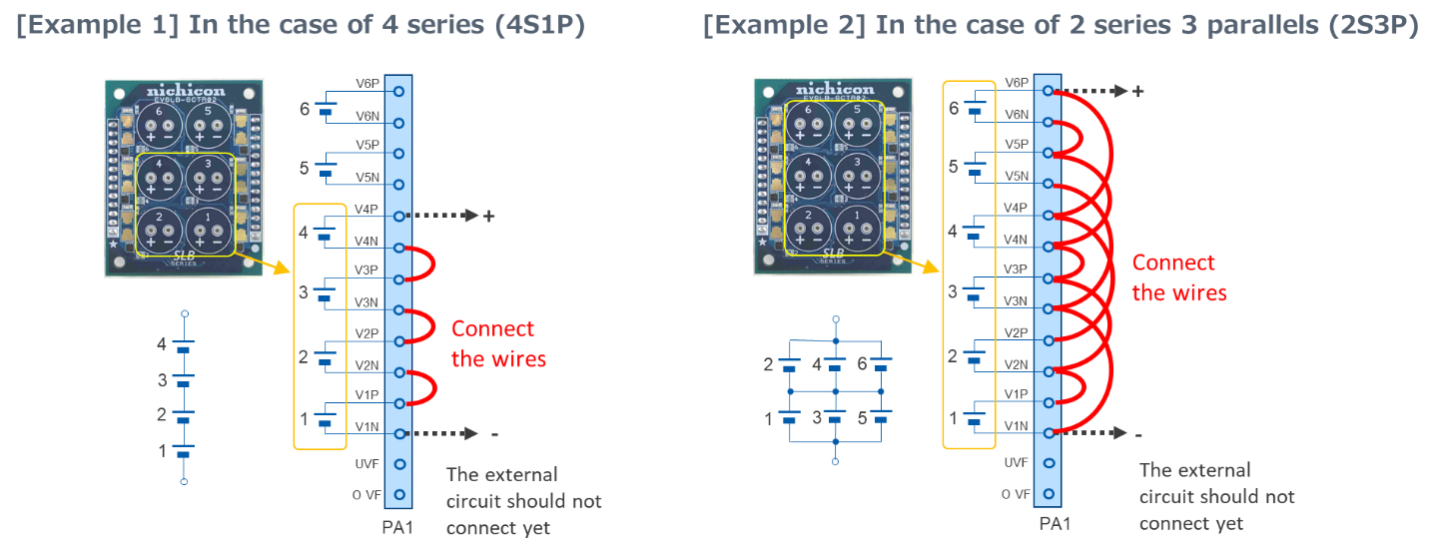

Fig 4-2-1 Example of wiring PA1

**Step2. Optimization of overcharge/over-discharge detection circuit**

The circuit configuration is needed to be optimized so that the overcharge/over-discharge signal circuit operates properly according to the connection configuration of the SLB series. This is done by removing the appropriate resistors (Rx20/Rx21, x=B to F), but this is not necessary if it is a simple series connection (2S1P to 6S1P) without parallel connection.

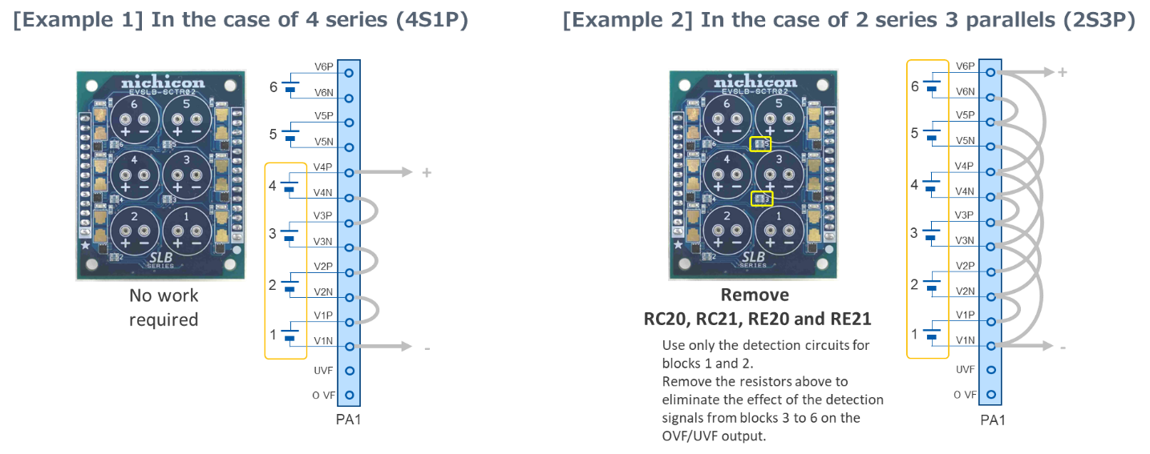

Fig 4-2-2 Overcharge/over-discharge signal circuit setting example

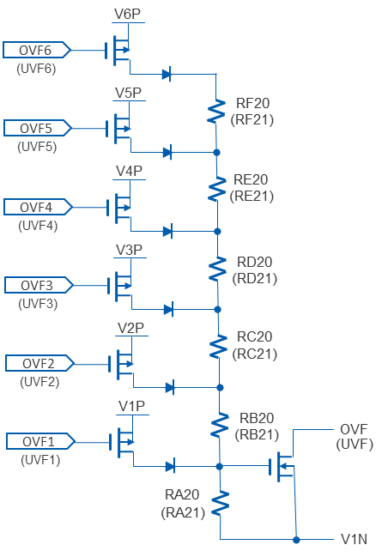

Fig 4-2-3 Configuration of overcharge/over-discharge signal transmission circuit

**Step3. Setting of voltage detection threshold**

Calculate the desired overcharge/over-discharge and cell balancing detection/release voltages using the information below as a reference, and replace the resistors as necessary.

If there is no need to change the default settings (listed in ***1. Specifications*** ), you can skip this step.

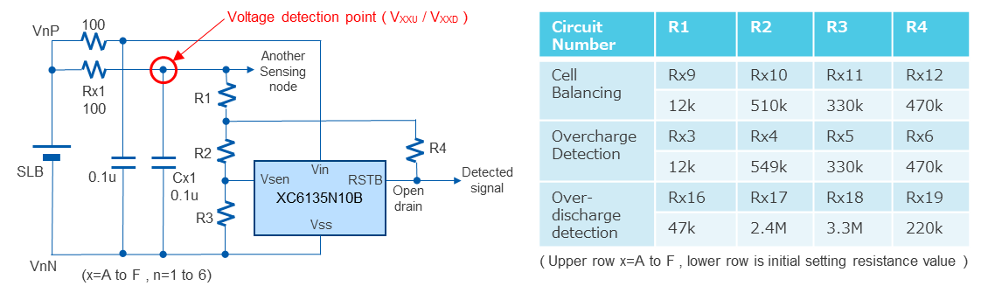

Fig 4-2-4 Configuration of overcharge, over-discharge and cell balancing voltage detection circuit

TOREX XC6135 datasheet:

<https://product.torexsemi.com/system/files/series/xc6135.pdf>

The XC6135N10B is an active low type voltage detection IC with a detection voltage of 1.0V, recovery hysteresis of 2mV (typ), N-ch open drain output. To simplify the following calculations, the effects of the IC's detection voltage accuracy and temperature characteristics will be omitted, but please consider these factors when deciding on the constants. Also, please select resistors with an accuracy of ±1% or less.

If the Vsen pin input resistance is Ri (=39MΩ typ) in the configuration in Figure 4.2.4, the detection voltage VXXD [V] and release voltage VXXU [V] can be calculated using the following formula.

(α: The magnification of the detection release voltage to the detection voltage of the voltage detection IC alone. In the case of the XC6135N10B, the IC detection voltage = 1V, and the IC detection release voltage = 1V + 2mV = 1.002V, so α = 1.002.)

$$V_{XXU}=α∙\left\{V_{XXD}+\frac{R1}{R4}\left(1+\frac{R2(R3+Ri)}{R3∙Ri}\right)\right\}$$

$$V_{XXD}=1+\frac{(R1+R2)(R3+Ri)}{R3∙Ri}$$

* It is preferable to select each constant of R1 to R4 so that the combined resistance value is within the

range of approximately 10kΩ to 10MΩ. Since the battery energy is constantly consumed through this resistor network, the larger the resistance value, the less current is consumed but noise resistance will decrease. Also, if the value of R4 is small, the circuit current that flows when low voltage is detected will be large, so setting this is preferable in terms of current consumption but the hysteresis width obtained will be smaller.

If the combined resistance of R1 to R4 is extremely low, the decoupling resistor of 100 Ω may affect the detection threshold.

* Due to the effect of R1, the IC output level during non-detection will be lower than VnP.

Do not select an extremely large value to avoid problems with driving the subsequent circuit

(100kΩ or less is recommended).

* The XC6135 is a device that detects when the voltage drops below a threshold, and when the voltage

rises above the hysteresis setting after detection, the detection is released. On this board, the inverted logic signal of XC6135 output is used for cell balance and overcharge detection circuits that start operating (or output a signal) when the voltage rises. In these two detection circuits, the XC6135 is always in a ?? state (the output FET is ON) where it is detecting a low voltage except when the cell balancing circuit is operating or the overcharge signal is being output. Therefore, current flows through R4, which increases the operating current compared to when cell balancing is in operation or when overcharge is detected.

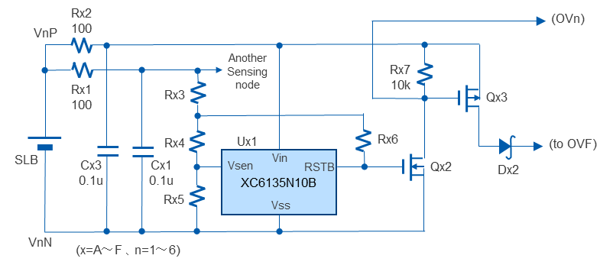

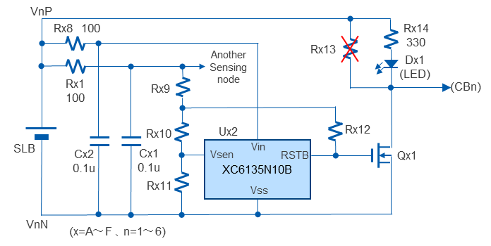

Fig 4-2-5 Cell balancing circuit Fig 4-2-6 Overcharge detection circuit

**Step4. Setting of cell balancing current**

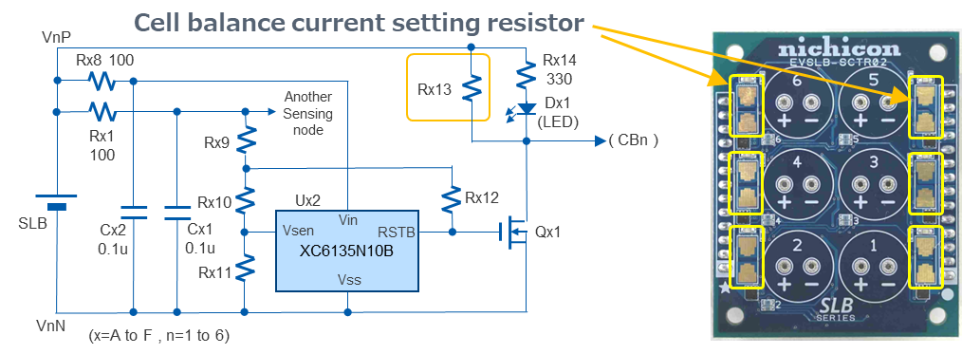Calculate the resistance value to get the desired cell balancing current to flow by using the formula below, and mount it on Rx9 (x=g to L) of the circuit block to be used. The mounting pads are compatible with sizes 0805 to 2512 (in inches).

**Rx13 [Ω] = VCB ／ ICB(start) [mA]**

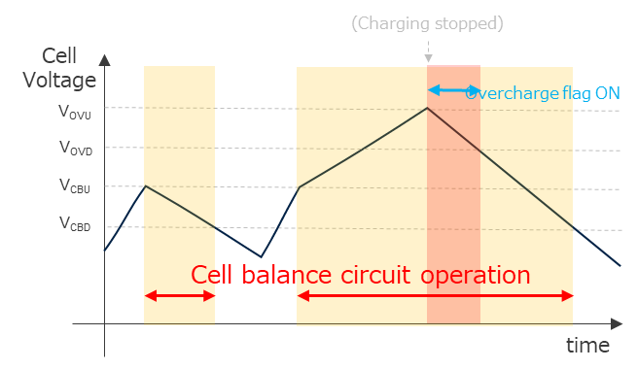Fig 4-2-7 Cell balancing circuit

Fig 4-2-8 Cell balancing operation

* The cell balancing current varies depending on the voltage of the corresponding cell.

To be precise, the cell balancing current value is set including the on-resistance of Qx3, but since the on-resistance of the MOSFET used in this circuit is 50mΩ or less, it will be no problem if you ignore the on-resistance when the cell balancing current is within the range of the commonly used value.

* During cell balancing, power consumption at Rx13 corresponds to the square of the cell balancing

current value multiplied by the resistance value, so care should be taken to prevent heat generation, etc., especially when the cell balancing current value is large.

When parallel connections are involved, it will work with only one cell balancing resistor among the parallel elements, but the temperature gradient will be smaller if all resistors are used to distribute the power consumption.

* If cell balancing is not required, Rx13 does not need to be mounted with a resistor.

However, in the default state, a few mA of current flows to drive the LED when the cell balance voltage level is detected, and this plays a small role in adjusting the cell balance. If you do not need this current, remove Rx14 (330 ohm). (in this case the cell balance indicator will not function)

**Step5. External circuit configuration**

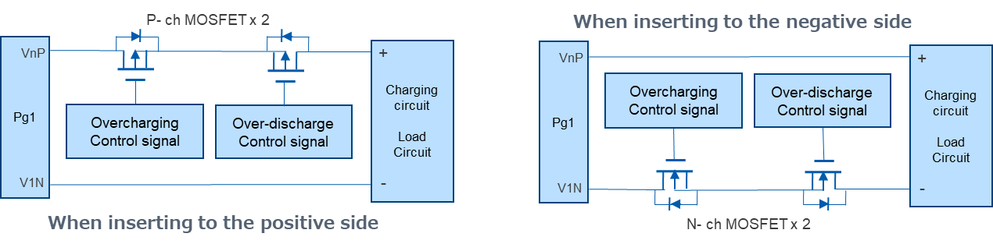This board has an overcharge/over-discharge detection function, but does not have a current cutoff function, so an external switch circuit or similar is required to stop overcharge or over-discharge. Please configure an appropriate circuit and insert it into the charge path (and/or) discharge path.

Fig 4-2-9 Example of the external switch circuit

* To prevent power being unexpectedly supplied when inserting the SLB series into the board,

it is preferable to:

Either keep the overcharge/over-discharge protection switch device OFF until the device is in use (for example, in the circuit shown above, short out the gate and source of each MOSFET)

or

Install a separate switch between the charging circuit and load circuit.

* When using a circuit like the one shown above, be careful not to impair the protection function by the

wiring of the device that controls the current cut-off MOSFET. In particular, if you insert a protection device on the negative side, you may need to devise a way to exchange signals between this board and the connected circuit, since the current is cut off by cutting the GND between this board and the connected circuit when the protection function is on.

* OVF/UVF signal (open drain output with a reference level V1N, ON when detected / Hi-Z when not

detected) output from this board can also be used as the overcharge/over-discharge control signal. Please take the above into consideration when configuring a circuit that will allow the current cutoff switch to operate properly.

* If overcharging and over-discharging can be avoided by the operating specifications of the external

circuit, a protection device is not necessarily required, but please consider carefully before deciding whether or not to include a protection circuit.

**Step6. Installing the SLB**

Insert the SLB12400L151 into the onboard socket of the circuit block to be used. When inserting, be sure to pay close attention to the polarity. (There is no protection against incorrect polarity insertion.)

This completes the preparation.

If you remove the measure to prevent unintended power supply in step 4, the connected circuit will start operating.

1. **Other information**

* The current consumption (per cell block) during operations in the initial state is as shown in the table below.

Table 5-1 Current consumptions on the initial setting

|  |  |  |
| --- | --- | --- |
| Item | Consumption | Measurement voltage |
| During normal operation  (overcharge/over-discharge not detected, cell balance circuit not operating) | Approx.  18.5μA | 2.50V |
| When the cell balance circuit is operating  (overcharge not detected)  * | Approx.  2.5mA | 2.65V |
| When overcharge is detected  (cell balancing circuit also operates)  * | Approx.  3.4mA | 2.75V |
| When over-discharge is detected | Approx.  35μA | 1.80V |

* If a cell balance current is set in Rx13, that current is added

* Part numbers are not printed on the board, so if you need to match the parts on the board with the

circuit numbers, please refer to the included parts layout board.

* Please treat the component constants used on this board as reference values ​​only (including threshold

settings that may deviate from the SLB rating when the accuracy of all circuit components and characteristic temperature fluctuations are accumulated in the worst case). Carefully examine the circuit constants, taking into consideration various conditions such as the materials used and the expected usage environment.

1. 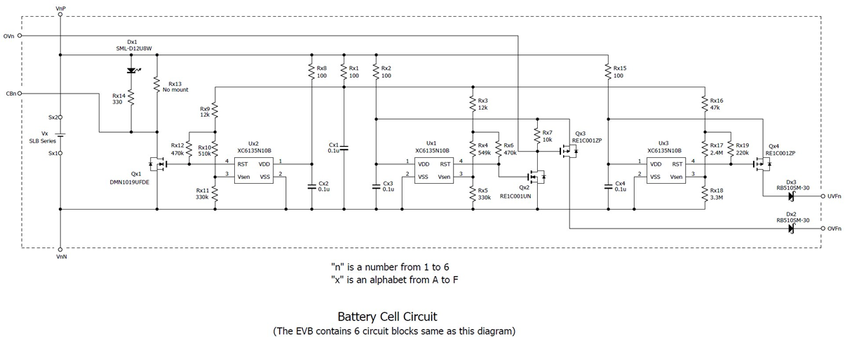**Schematics**

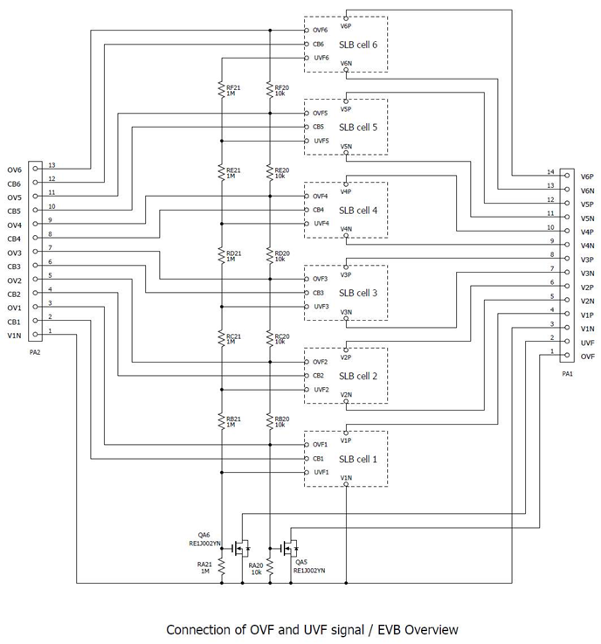

1. **Parts list**

Table 7 Parts list

|  |  |  |  |  |
| --- | --- | --- | --- | --- |
| Ref No. | Component | Value | Manufacturer | Description |
| Cx1 | Capacitor (0603) | 100nF | Murata | GCJ188R71H104KA12D |
| Cx2 | Capacitor (0603) | 100nF | Murata | GCJ188R71H104KA12D |
| Cx3 | Capacitor (0603) | 100nF | Murata | GCJ188R71H104KA12D |
| Cx4 | Capacitor (0603) | 100nF | Murata | GCJ188R71H104KA12D |
| Dx1 | LED | Red | Rohm | SML-D12U8WT86 |
| Dx2 | Schottky barrier diode |  | Rohm | RB510SM-30T2R |
| Dx3 | Schottky barrier diode |  | Rohm | RB510SM-30T2R |
| PA1 | Pin header | 14pin | Adam Tech | PH1-14-UA |
| PA2 | Pin header | 13pin | Adam Tech | PH1-13-UA |
| Qx1 | MOSFET | n-ch | Diodes | DMN1019UFDE-7 |
| Qx2 | MOSFET | n-ch | Rohm | RE1C001UNTCL |
| Qx3 | MOSFET | p-ch | Rohm | RE1C001ZPTL |
| Qx4 | MOSFET | p-ch | Rohm | RE1C001ZPTL |
| QA5 | MOSFET | n-ch | Rohm | RE1J002YNTCL |
| QA6 | MOSFET | n-ch | Rohm | RE1J002YNTCL |
| Sx1 | Through hole socket | - | Mac8 | AF-0.7(H) |
| Sx2 | Through hole socket | - | Mac8 | AF-0.7(H) |
| Ux1 | IC (Voltage detector) |  | TOREX | XC6135N10BNR-G |
| Ux2 | IC (Voltage detector) |  | TOREX | XC6135N10BNR-G |
| Ux3 | IC (Voltage detector) |  | TOREX | XC6135N10BNR-G |
| Rx1 | Resistor (0603) | 100ohm | KOA | RK73H1JTTD1000F |
| Rx2 | Resistor (0603) | 100ohm | KOA | RK73H1JTTD1000F |
| Rx3 | Resistor (0603) | 12kohm | KOA | RK73H1JTTD1202F |
| Rx4 | Resistor (0603) | 549kohm | KOA | RK73H1JTTD5493F |
| Rx5 | Resistor (0603) | 330kohm | KOA | RK73H1JTTD3303F |
| Rx6 | Resistor (0603) | 470kohm | KOA | RK73H1JTTD4703F |
| Rx7 | Resistor (0603) | 10kohm | KOA | RK73H1JTTD1002F |
| Rx8 | Resistor (0603) | 100ohm | KOA | RK73H1JTTD1000F |
| Rx9 | Resistor (0603) | 12kohm | KOA | RK73H1JTTD1202F |
| Rx10 | Resistor (0603) | 510kohm | KOA | RK73H1JTTD5103F |
| Rx11 | Resistor (0603) | 330kohm | KOA | RK73H1JTTD3303F |
| Rx12 | Resistor (0603) | 470kohm | KOA | RK73H1JTTD4703F |
| Rx13 | Resistor (2512) | → | → | Need to mount an appropriate value resistor |
| Rx14 | Resistor (0603) | 330ohm | KOA | RK73H1JTTD3300F |
| Rx15 | Resistor (0603) | 100ohm | KOA | RK73H1JTTD1000F |
| Rx16 | Resistor (0603) | 47kohm | KOA | RK73H1JTTD4702F |
| Rx17 | Resistor (0603) | 2.4Mohm | KOA | RK73H1JTTD2404F |
| Rx18 | Resistor (0603) | 3.3Mohm | KOA | RK73H1JTTD3304F |
| Rx19 | Resistor (0603) | 220kohm | KOA | RK73H1JTTD2203F |
| Rx20 | Resistor (0603) | 10kohm | KOA | RK73H1JTTD1002F |
| Rx21 | Resistor (0603) | 1Mohm | KOA | RK73H1JTTD1004F |

"x" can be A, B, C, D, E, or F (all six circuit blocks have the same circuit configuration and constants).

**Revision history**

|  |  |  |
| --- | --- | --- |
| Revision No. | Date | Description |
| 0.80 | Nov.8th, 2024 | Preliminary version |
| 1.00 | Nov.27th, 2024 | Release version |
|  |  |  |
|  |  |  |